 | 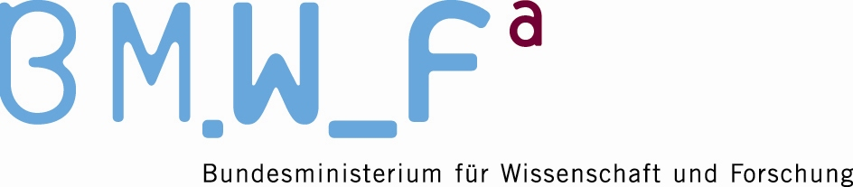

3rd Meeting of the 2009-2012 BFUG Working Group
“International Openness -
The European Higher Education Area in a Global Context”

27 May 2010, 14.00 – 17.30

Austrian Federal Ministry of Science and Research
Teinfaltstr. 8, 1010 Vienna, E01

DRAFT AGENDA

14.00 Welcome and opening

- Adoption of the Agenda

- Minutes of the WG meeting on 25 January 2010

- Outcome of the BFUG meeting

- Feedback on & follow-up to the Second Bologna Policy Forum

- Information on the first meeting of the EHEA Information & Promotion Network

15.30-16.00 Coffee break

- Work plan 2010-2012

- Reports on activities relevant to the Working Group (written contributions only)

- Any other business

  - End of the meeting

19.00 Joint dinner with members of the EHEA Information & Promotion Network

