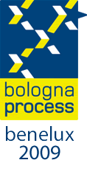

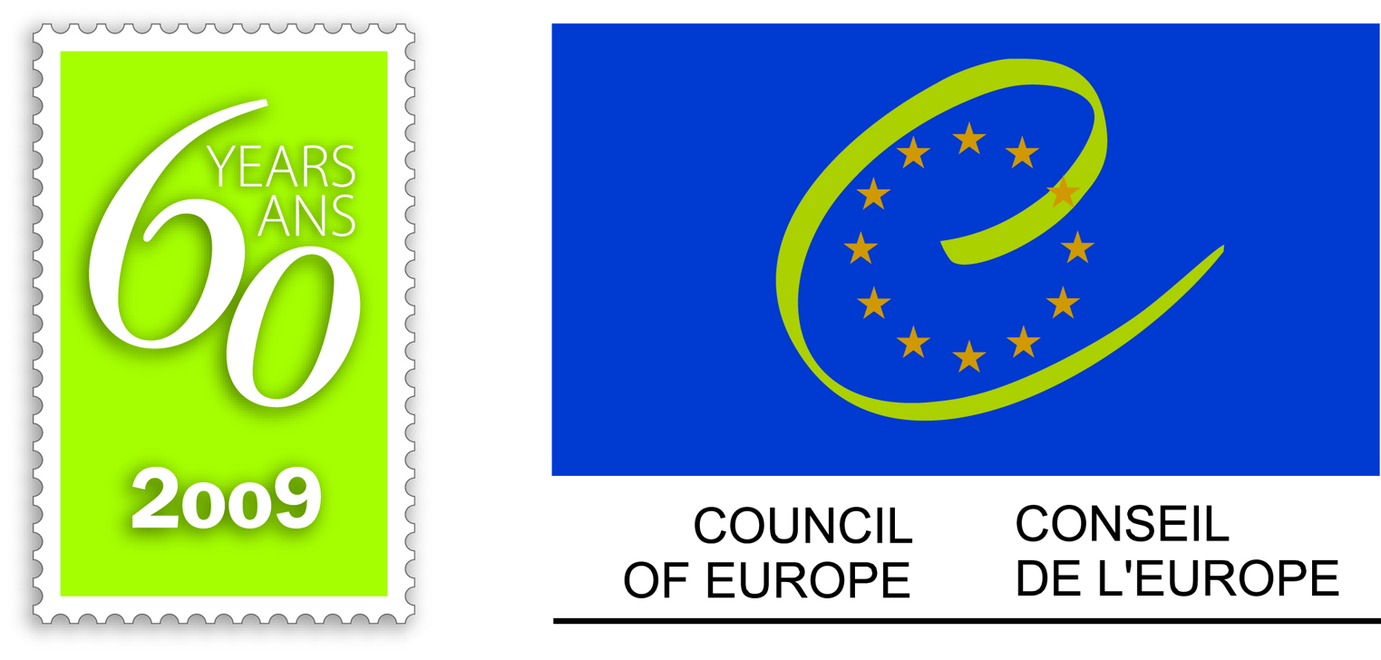
DGIV/EDU/HE (2009) OJ 10
Orig. Eng.
Strasbourg, October 8, 2009

BOLOGNA PROCESS
Development of Qualifications Frameworks
Meeting of National correspondents

Strasbourg, November 9 (09.00 hrs) -10 (13.00 hrs), 2009
G01 - Agora Building, Council of Europe
.

DRAFT AGENDA

Directorate General IV: Education, Culture and Heritage, Youth and Sport (Directorate of Education and Languages – Higher Education and Research Division)

Distribution: Working Group

Within the Bologna Process, the Council of Europe was charged with following the developments of National Qualifications Frameworks. Since 2007, the Council of Europe has chaired the Working group on qualifications frameworks and a report was presented for the Leuven/Louvain la Neuve conference.
From all this work, one of the recommendations was to organize a meeting of National correspondent with the following aims:
- To provide updated information on QF development both on European and on national levels
- To offer a space for exchange of experiences and good practices
- To identify the challenges and difficulties on NQF developments
- To reflect on further developments

Background documents:

The framework of qualifications of the European Higher Education Area
http://www.bologna-bergen2005.no/EN/BASIC/050520_Framework_qualifications.pdf

The report of the Coordination Group on Qualifications Frameworks to the 2009 ministerial conference of the Bologna Process http://www.ond.vlaanderen.be/hogeronderwijs/bologna/conference/documents/2009_QF_CG_report.pdf

Synthesis of national reports on Qualifications Frameworks to the 2009 ministerial conference of the Bologna Process
http://www.ond.vlaanderen.be/hogeronderwijs/bologna/conference/documents/Synthesis_NQF_Reports_March2009.pdf

Sunday, November 8

Arrival of participants

Monday, November 9
09 00 – 9 30 Registration
09 30 Official opening
Welcome speeches:
- Myrna Smitt, Chair of the BFUG
- Sjur Bergan, Chair of the Bologna working group on qualifications frameworks
10 00 From Leuven/ Louvain la Neuve the role of Qualification framework developments within the Bologna Process
Sjur Bergan,
10 45 Developments in the European Qualifications Framework for lifelong learning, Carlo Scatoli, European commission
11 15 Coffee
11 45 Actual developments of Qualifications frameworks. Round table
- A regional perspective: South East European Network on QF, Croatia,
Prof Mile Dzelalija
- A country which self certified: Ireland, John Scattergood
Discussion
13 00 Lunch
14 30 14 50 introduction of the Working groups
· Presentation of the Synthesis of the SWOT
Jean Philippe Restoueix, Council of Europe
· Presentation of the reporting system
14 50 – 16 30 Working group aiming to arrive to one SWOT poster by group
Regrouping by level of developments:
- Implementation and self certification: countries which are in the final steps of their NQF developments
- Development and stakeholder involvement: countries which are in the middle of the process
- Launching the work: countries which are in the earlier stages of the process
16 30 – 16 50 Coffee break
16 50 - 17 45 Presentation of the reports
Discussion

Tuesday, November 10
09 30 – 10 45 The self certification process: some practices
Discussion
10 45 – 11 15 Coffee break
11 50 – 13 00 Next steps
The Dublin Conference: presentation of the aims and objectives, John Scattergood
Next steps on the agenda of the Working group on QF, Sjur Bergan
13 00 Closing

