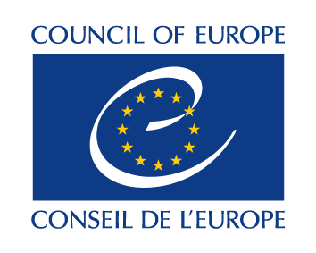

Seminar on

Structural reforms in the
European Higher Education Area: challenges and opportunities

Draft programme

18 November 2014
Minsk

Tuesday 18 November 2014

10 00 – 10 20 Opening of the seminar

- Welcome by Mr Sergej Maskevich, Minister of Education of the Republic of Belarus
- Welcome by Ms Katia Dolgova-Dreyer, Head of the Regional and Bilateral Cooperation Unit, CIS countries and Central Asia, Education Department, Directorate of Democratic Citizenship and Participation, Council of Europe

Session 1 European Higher Education Area: topical issues
Chaired by the representative of Belarus

10 20 – 10 50 Quality assurance in the European Higher Education Area, by Ms Aurelija Valeikiene, Deputy Director, Centre for Quality Assessment in Higher Education, Lithuania
Discussion

10 50 – 11 20 Structural reforms in the European Higher Education Area, by Mr Bartłomiej Banaszak, Ministry of Science and Higher Education, Poland; Co-Chair of the EHEA Structural Reforms Working Group and member of the BFUG
Discussion

11 20 - 11 50 Structural reforms in the higher education system of Belarus by Mr Vadim Bogush, First Deputy Minister of the Republic of Belarus
Discussion

11 50 – 12 10 Coffee break

12 10 – 12 40 European Union support to higher education modernisation and academic cooperation and the opportunities under Erasmus + by Ms Marta Touykova, DG EAC, European Commission
Discussion

12 40 – 14 10 Lunch

Session 2 European Higher Education Area: challenges and opportunities
Chaired by Ms Katia Dolgova-Dreyer

14 10 – 14 40 Quality assurance: examples of good practices by Ms Keti Tsotniashvili, Analytical coordinator, National Center for Education Quality Enhancement (NCEQE), Georgia
Discussion

14 30- 15 00 Student participation in higher education governance by Mr Maksimas Milta, Executive Committee Member 2014/15, European Students’ Union
Discussion
15 00 – 15 30 Coffee break

15 30 – 16 00 Preparation for the 2015 Bologna Ministerial meeting by Mr Hayk Sargsyan, Bologna Secretariat
Discussion

16 00 – 16 30 Wrap-up and closing of the seminar

