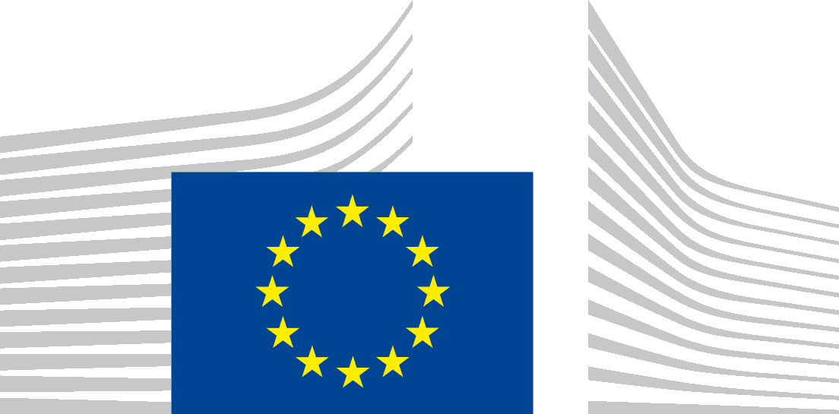 | EUROPEAN COMMISSION  Directorate-General for Education and Culture  Lifelong learning: higher education and international affairs  Higher education; Erasmus

BFUG_CY_BA_33_9f

EC Information on HE Policy Developments

1 Supporting growth and jobs – an agenda for the modernisation of Europe's higher education systems'
High Level Group on the Modernisation of Higher Education
On September 18th 2012, the European Commission will launch a High Level Group on the Modernisation of Higher Education. The group will be chaired by former Irish President Mary McAleese. The high level expertise of the group will inform policymaking on key higher education issues, initially on the theme of excellence in teaching, a hitherto under-explored dimension in higher education. The group will have a remit of making recommendations to support policy reforms and innovations in practice so that all students can benefit from excellent teaching that provides high-level skills, and all institutions can adopt new ways of envisaging and delivering such excellence. The recommendations will be published in an easily accessible format designed for delivery to policy makers but also to institutions and the public, for maximum impact. The group is composed of eight members including the chair.

2 Europe 2020 Strategy
As part of the Europe 2020 Strategy, the Commission proposed (30 May 2012) recommendations to Member States in the area of education and training focussing on:
- countries' performance on the headline targets, i.e. early school leaving and tertiary or equivalent attainment, including early school leaving strategies and quality of higher education;
- VET reforms, including apprenticeships, in the follow-up of the Youth Opportunities Initiative/Youth Action teams;
- addressing challenges related to specific disadvantaged groups.
Nine countries received recommendations on higher education.
http://ec.europa.eu/europe2020/making-it-happen/country-specific-recommendations/index_en.htm

3 Erasmus for All
Erasmus for All is the new EU programme for education, training, youth and sport proposed by the European Commission on 23 November 2011. The proposal is now under discussion by the Council (where Ministers agreed a 'partial general approach' at the Council meeting of May 2012) and the European Parliament.
Erasmus for All would bring together all the current EU and international schemes for education, training, youth and sport, replacing seven existing programmes with one. This will increase efficiency, make it easier to apply for grants, as well as reducing duplication and fragmentation. It is due to start in 2014.
Up to 5 million people, almost twice as many as now, could get the chance to study or train abroad with a grant from Erasmus for All. Among them would be nearly 3 million higher education and vocational students. Full-time Masters' students would also benefit from a new loan guarantee scheme set up with the European Investment Bank Group.
http://ec.europa.eu/education/erasmus-for-all/

4 Benchmarks for employability and learning mobility in higher education:
In May 2012, Ministers agreed on a new benchmark for employability of graduates. The benchmark will help monitor performance and identify best practice in helping graduates make the crucial step from education in jobs. An average of at least 82% of graduates (20-34 year olds) should be employed no more than three years after they have completed education.
In November 2011, Ministers agreed on a new benchmark for learning mobility in higher education and in vocational education and training - at least 20 % of higher education graduates in the EU should have had a period of higher education-related study or training (including work placements) abroad by 2020. This would represent a minimum of 15 higher education credits (ECTS) or a period lasting a minimum of three months.
The benchmarks complement five existing reference points on European performance - adult participation in lifelong learning (15% by 2020), tertiary level attainment (40% by 2020), early school leaving (10% by 2020), low achievers in basic skills (10%) and early childhood education.
http://www.consilium.europa.eu//uedocs/cms_data/docs/pressdata/en/educ/130142.pdf
http://www.consilium.europa.eu/uedocs/cms_data/docs/pressdata/en/educ/126380.pdf

5 Professional Qualifications Directive:
On 19 December 2011, the Commission adopted a legislative proposal for modernising Directive 2005/36/EC on the recognition of professional qualifications. The Directive is expected to be agreed by the European Parliament and Council by end of 2012. Concrete effects can be expected for 2014. One innovation in the draft directive is a proposal that national authorities can now use the number of ECTS credits in determining the equivalence of qualifications, echoing the on-going shift away from educational inputs (hours of study) to learning outcomes in national education systems. The proposal also clarifies the relationship between the five levels of education in the directive and the eight levels of the EQF.
http://ec.europa.eu/internal_market/qualifications/policy_developments/index_en.htm

6 EIT
Twelve new members of the governing board of the European Institute of Innovation and Technology were appointed end of July 2012 by the European Commission. The governing board is responsible for the overall strategy and for the selection, coordination and evaluation of the ´Knowledge and Innovation Communities´(KICs), the public-private partnership innovation hubs at the heart of the EIT.
http://ec.europa.eu/education/news/20120724_en.htm

