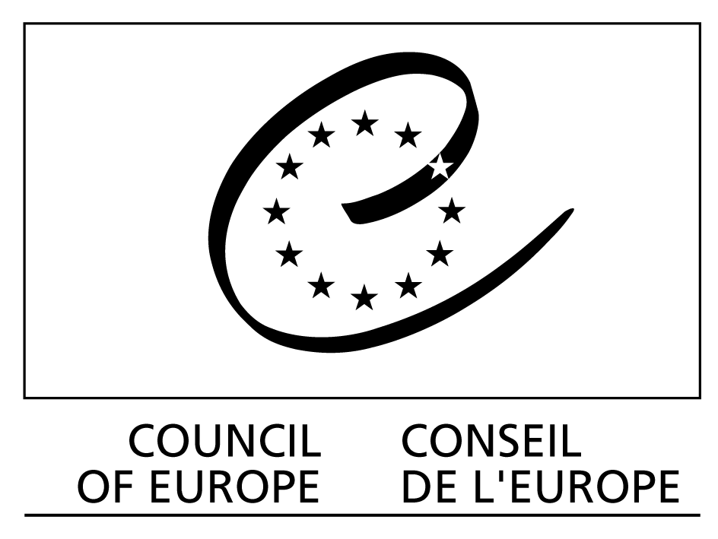
Doc. Code: BFUG_DK_AZ_30_11c

Orig. Eng.
Strasbourg, March 12, 2012

Bologna Follow Up Group

København, March 19 - 20, 2012

THE CONTRIBUTION OF THE COUNCIL OF EUROPE TO THE EUROPEAN HIGHER EDUCATION AREA

UPDATE

Directorate General II: Democracy – Directorate of Democratic Citizenship and Participation: Education Department

Distribution: BFUG
General
Document available on http://www.coe.int/DGIVRestricted

INTRODUCTION

The present document gives an overview of the Council of Europe’s contribution to the European Higher Education Area between the Ministerial meetings in Budapest/Wien in March 2010 and Bucureşti in April 2012. It is updated as of mid-March 2012. To save space, it does not provide a full picture of the Council’s contribution but rather focuses on recent developments.

Over the past years, the Council of Europe contributions to the Bologna Process have focused on:

- active participation in the BFUG and Board as well as in working groups;
- taking responsibility for coordinating the sharing of experience in the elaboration of national qualifications frameworks compatible with the overarching framework of qualifications of the EHEA, inter alia by chairing and providing the Secretariat for the Bologna Working Group on Qualifications Frameworks and participating in the work of the EQF Advisory Board;
- recognition policy, including the role of the Lisbon Recognition Convention as the only legally binding text of the Bologna Process;
- specific policy areas of relevance to the Bologna Process as well as to the basic values of the Council of Europe, in particular the public responsibility for higher education and research, the responsibility of higher education for democratic culture, higher education governance and quality assurance;
- bilateral and regional activities assisting newer member states with the implementation of “EHEA inspired” policies at national level. These activities have in particular focused on countries that acceded to the Bologna Process in 2003 and later.

The Council of Europe intends to continue to contribute to the European Higher Education Area along these lines. Currently, in addition to chairing the working group on qualifications frameworks, the Council of Europe contributes to the working groups on recognition, international openness and transparency instruments.

QUALIFICATIONS FRAMEWORKS

The role of the Council of Europe is to facilitate the sharing of experience so that the competent national authorities can benefit from relevant experience from other countries to the extent that the national authorities see fit to do so. This is in keeping with the London Communiqué:

We note that some initial progress has been made towards the
implementation of national qualifications frameworks, but that much more effort is required. We commit ourselves to fully implementing such national qualifications frameworks, certified against the overarching Framework for Qualifications of the EHEA, by 2010. Recognising that this is a challenging task, we ask the Council of Europe to support the sharing of experience in the elaboration of national qualifications frameworks. We emphasise that qualification frameworks should be designed so as to encourage greater mobility of students and teachers and improve employability.

as well as with the Leuven/Louvain-la-Neuve Communiqué:

The development of national qualifications frameworks is an important step towards the implementation of lifelong learning. We aim at having them implemented and prepared for self-certification against the overarching Qualifications Framework for the European Higher Education Area by 2012. This will require continued coordination at the level of the EHEA and with the European Qualifications Framework for Lifelong Learning. Within national contexts, intermediate qualifications within the first cycle can be a means of widening access to higher education. (para. 12).

A separate update on the activities related to qualifications frameworks is submitted to the BFUG and will not be repeated here except to underline the main points:

- the network of national correspondents met in Strasbourg in March and in Warszawa in November 2011. The latter was the second meeting held jointly with the National Coordination Points (NCPs) of the EQF and hence coorganized with the European Commission. The next meeting of the Network will be held in Strasbourg on May 22 and will, among other things, consider how the work on qualifications frameworks could be organized in the 2012 – 15 work program, with a view to submitting a proposal to the August 2012 BFUG meeting;
- the report by the working group was adopted by the BFUG in January 2012. At this meeting, which took place in København, the Council of Europe also organized a thematic BFUG session on qualifications frameworks;
- most – but not all – EHEA members seem to be able to meet their commitment of developing their national frameworks and prepare them for self certification by 2012, or at least to come close to meeting this commitment. Nevertheless, in addition to the relatively few countries that are clearly far from meeting their commitments, a larger group of countries is at a stage where they can come close to meeting their commitments if they sustain a steady pace of reform but where they could also fail to meet their commitment if the work on their national framework is not carried forward as hoped.

RECOGNITION OF QUALIFICATIONS

The Council of Europe/UNESCO Recognition Convention is the only legally binding text of the Bologna Process. As of March 12, 2012, all EHEA members except Greece had ratified the Convention. It should be noted that Greece had also not signed the Convention. The total number of ratifications – including non-members of the Bologna Process – is now 52, while three further countries – Canada, Tajikistan and the United States – have signed but not yet ratified it. The development of policy and practice in recognition is furthered by the ENIC and NARIC Networks, which are served jointly by the Council of Europe, UNESCO and the European Commission.

The Council of Europe will continue to play an active and leading role in recognition policy, in close cooperation with UNESCO and the European Commission. Recognition issues in the Bologna Process will remain high on the agenda of the ENIC and NARIC Networks, which – through their connection to other UNESCO regions – will also play an important role in facilitating recognition between qualifications from the EHEA and those from other areas of the world.

The ENIC and NARIC Networks will continue to consider the impact of qualifications frameworks on the recognition of qualifications, and qualifications frameworks will be an element in developing the understanding of the concept of substantial differences.

The Bureau of the Lisbon Recognition Convention Committee is preparing a subsidiary text on the role of qualifications frameworks in facilitating recognition for submission to the next meeting of the Convention Committee.

The 2012 meeting of the ENIC and NARIC Networks will be hosted by the Spanish ENIC/NARIC in Toledo in June. A one day conference marking the 15th anniversary of the adoption of the Council of Europe/UNESCO Recognition Convention will be held in conjunction with this meeting.

NEW STEERING COMMITTEE FOR EDUCATIONAL POLICY AND PRACTICE

Until the end of 2011, the Council of Europe had two steering committees covering various aspects of education: the Steering Committee for Higher Education and Research (CDESR) and the Steering Committee for Education (CDED).

As part of the reform of the Council of Europe, a single steering committee will, as of 2012, cover all aspects and fields of education. The new committee, known as the Steering Committee for Educational Policy and Practice (CDPPE), will be a pan-European forum for delegations of the 50 States party to the European Cultural Convention, 47 of which are also members of the EHEA. All States are invited to appoint delegations made up of two representatives, one of whom should cover general and one higher education. The CDPPE Bureau will be composed of 6 members of the Committee and in addition two penetrative of the academic community and two representatives with NGOs with observer status with the committee will participate in the meetings of the Bureau.

The first plenary session of the CDPPE will be held in Strasbourg on March 27 – 29, 2012. it will, among other things, elect its Chair, Vice Chair and Bureau. It will also consider draft recommendations on the role of public authorities in ensuring academic freedom and institutional autonomy and on the right to quality education.

STUDENT PARTICIPATION

In cooperation with the Armenian authorities and ESU, the Council of Europe organized a Bologna conference on student participation in higher education governance in Aghveran on December 8 – 9, 2011. The objective of the conference was to look into topical issues of student participation in higher education governance and quality assurance, from institutional to national and international levels, outlining the main problems and obstacles, looking for examples of good practice and proposing a way forward. The conference report will be made available to the BFUG.

CONFERENCE ON “REIMAGINING DEMOCRATIC SOCIETIES”

The Council of Europe organized a conference on “Reimagining Democratic Societies: a New Era of Personal and Social Responsibility?” in Oslo on June 27 – 29, 2011 jointly with the US Steering Committee of the International Consortium for Higher Education, Civic Responsibility and Democracy; the International Association of Universities, the University of Oslo and the European Wergeland Centre. The conference was also a part of the events marking the 200th anniversary of the University of Oslo. It raised a number of broader issues of clear relevance to the European High Education Area, which may be summarized in one key question: what purposes should the structural reforms that are a key element of the EHEA ultimately serve?

This conference is part of the cooperation between different partners committed to promoting democracy, human rights and the rule of law as well as social cohesion and intercultural dialogue, and their belief in the key role of education in furthering these goals. The main aims will be:

- To strengthen the role of higher education in furthering democratic citizenship
- To identify concretely the role that higher education can play in reimagining democratic societies
- To stress the importance of the involvement of the different stakeholders: academic, administrations, students, local communities
- To develop further strategies to strengthen this role

We plan to publish a book based on the conference in the Council of Europe Higher Education Series, to be co edited by Ira Harkavy (US Steering Committee), Hilligje van’t Land (IAU) and Sjur Bergan (Council of Europe).

WORK WITH SPECIFIC COUNTRIES OR REGIONS

Within the Bologna Process, the Council of Europe has been given specific responsibility for cooperation with the newer members of the Process, and the Council has played an important role in developing the Bologna Process into a truly European Higher Education Area.

At present, the Council of Europe is in the final phases of negotiating a major project on higher education reform in Turkey. The Council also provides advice on the development of the national qualifications framework of Armenia and Ukraine.

As a part of the Ukrainian Chairmanship of the Council of Europe, a high level Education Forum was held in Kyiv on September 22 -23. The Forum focused on the role of education in developing a culture of “living together”. As a part of the conference, Ministers of the region also met to consider the development of qualifications frameworks.
On December 1 – 2, 2011, the Free International University of Moldova hosted a seminar on the implementation of the European Higher Education Area in Moldova. The event was organized by the Ministry of Education of Moldova and the Council of Europe in cooperation with the Bologna Secretariat. The participants represented higher education institutions from the Republic of Moldova and abroad, of public authorities and international institutions. They reviewed the higher education reform in Moldova in order to ensure convergence with the principles of the EHEA. A biennial Forum for the Modernization of Higher Education will be organized in order to analyze the achievements, challenges, reform actions and policies needed to move forward, and public discussion of the national qualifications framework with external expertise and certification of compliance to the QF-EHEA and the EQF shall be promoted.

REFORM OF THE COUNCIL OF EUROPE

The Council of Europe’s Secretary General, Mr. Thorbjørn Jagland, was elected in autumn 2009 on a strong program of institutional reform. An important part of this program has now been adopted by the Committee of Ministers and will be implemented over the coming months – as of October 1 for the reorganization of the Secretariat and as of January 1, 2012 for the reorganization of steering committees (on the latter, see above).

As a part of the reorganization of the Secretariat, the Secretariat structure has been adapted to the structure of the 2012 – 13 work program. Ms. Snežana Samardžić-Marković was recently appointed Director General of DG II: Democracy and it is expected that she will take up her new duties in the course of April 2012.

Within the DG II, the education program falls under the responsibility of the new Directorate for Democratic Citizenship and Participation, which will regroup most of what were previously the Directorates of Education and Languages and of Youth and Sports. The Directorate is headed by the previous Director of Education and Languages, Ms. Ólöf Ólafsdóttir, while Sjur Bergan heads the new Department of Education.

PUBLICATIONS

The Council of Europe Higher Education Series is by now well established. Several of the volumes published since December 2004 address key issues in the Bologna Process, and we will aim to continue to contribute to the EHEA also through the Higher Education Series. The most recent volume in the series was published in late spring 2011:

Sjur Bergan: Not by Bread Alone (Strasbourg 2011: Council of Europe Publishing Council of Europe Higher Education Series no 17).

WEB SITE

The Council of Europe’s higher education web site presents an up to date overview of the Council’s activities as well as of higher education policies in Europe. It can be accessed at http://www.coe.int/t/dg4/highereducation/Default_en.asp.

A constantly updated list of ratifications and signatures may be found at http://conventions.coe.int/; search for ETS 165.
http://www.coe.int/t/dg4/highereducation/Resources/HEseries_en.asp

