[www.ehea.info]
Presentation of the European Higher Education Area website

Contents

I. How was the website designed? 3
II. Changes operated for the new website 6
III. Back-office tutorial 7
1. HOW TO ACCESS THE BACKOFFICE? 7
2. DOCUMENTS’ MANAGEMENT – LOADING DOCUMENTS 8
3. DOCUMENTS’ MANAGEMENT – EDITING DOCUMENTS 12
4. CONTACTS’ MANAGEMENT – ADDING A NEW CONTACT 16
5. CONTACTS’ MANAGEMENT – VIEWING THE CONTACTS 18
6. EVENTS’ REGISTRATION – REGISTER TO AN EVENT 20
7. EVENTS’ REGISTRATION – VIEW REGISTRATIONS 22
8. GANTT 25
9. INVITATION LOG 29
10. TASKS 34
IV. Tutorials for the countries and WGs/Networks public editable content 37
V. Templates for National pages and WGs/Networks pages 42

How was the website designed?

In the “Bologna beyond 2010”, chapter 3 states the need for a permanent website of the EHEA to be established.

Accordingly, the EHEA official website must be country-neutral and must have a structure easily applicable on the long-run for the purpose of archiving all the existent information, among others.

In the website design process, we have started with a basic analysis of the previous Bologna Process websites, followed by the identification of the main requirements to be met by the new official EHEA website.

Therefore, we have come to the conclusion that the website should meet the following purposes:
- Providing information for the stakeholders of the EHEA;
- Providing the means of communication to ensure the EHEA openness towards a global audience;
- Maintaining a well-structured archive of all the Bologna Process/ EHEA relevant existent information;
- Providing an accessible management platform for the work of the BFUG and BFUG substructures.

Hence, the main tools to be incorporated in the EHEA website are:
- Tag Cloud - based on frequent search and article description made by the secretariat;
- The FAQs section available;
- The Glossary available, including the most frequently asked acronyms;
- A useful Search option available on the website;
- Well-structured information, on the main thematic areas;
- A Really Simple Syndication (RSS) option, used to publish frequently updated works in a standardized format;
- The archive is structured in an accessible and easily viewable manner;
- A complex and yet user-friendly backoffice designed particularly for the various user categories:
  - BFUG members;
  - BFUG substructures;
  - Bologna Secretariat.
- Easy to administer – Content Management System – CMS – giving the possibility to administer different pages for the EHEA/ BFUG members
We envisage a continuous update of the website, based on the received feedback, so as to customize it to the changing needs resulting from the EHEA development.
Except for the main functions of the EHEA official website, there is the possibility to make use of it as a means of collecting data relevant for the Reporting activity. Therefore, it would be possible, if decided so, to integrate a restricted area intended to be used for an on-line survey or as an application for the reporting activity aimed at providing background information for the Ministerial Conference of 2012.

The new website of the Bologna Process was built around 3 main keywords, each fulfilling a specific objective:
1. INFORMATION, together with visibility and transparency
2. ENGAGEMENT, together with openness and involvement
3. CONTINUITITY, together with a long term vision
1. INFORMATION

We want to communicate with the EHEA’s member states representatives, academic communities, other stakeholders, as well asthe global audience, through the website, both about the Bologna Process in itself (its values, aims and characteristics) and about its progress and results.
We want to ensure the visibility of the EHEA in all its aspects and with all its components.
We want to make the information transparent and easy to grasp for a larger audience, in a friendly manner.

2. ENGAGEMENT
We aim at constantly increasing the number of visitors of the EHEA website, by providing them with a series of options and functions, tailored to their needs. These new website tools will ensure a gratifying visitor’s experience and create the connection that will make them rely on the permanently updated information on the website.
We want to help our audiences contribute to the Process and understand in an interactive manner what is at stake for them.

3. CONTINUITITY
We want to create a website that will serve the EHEA in the long run, providing continuity even in the context of the various countries chairing and supporting the BFUG work.
We want to create an electronic environment that will be endorsed by the BFUG and passed on every two years. This way, the website will not represent a significant challenge in itself; it will support the communication interests in the most natural manner possible and with a long term vision in mind.

Changes operated for the new website

- the website is a comprehensive / neutral one from the geographical point of view (www.ehea.info instead of (e.g.:) http://www.ond.vlaanderen.be/hogeronderwijs/bologna/);
- BFUG members will be able to edit their profile;
- all WGs and Networks will have the opportunity to post content on the website (not compulsory);
- all the documents from the previous websites of the Bologna Process will be archived on the new website, thus making sure that all the necessary information is stored in one place;
- For the update of the BFUG calendar, an electronic template for events will be available online, in order to have at least some minimal information posted on the website;
- The main menu has been restructured, for a more intuitive browsing of the website – for an overview, please see Annex 1 (Sitemap);
- The events tab, listing the past/future events;
- Backoffice: powerful tool designed particularly for the different needs of specific user groups (Secretariat, BFUG members, WG/Network members, etc);
- The BFUG Work Programme is updated with the new directions stemming from the Leuven/ Louvain la Neuve Ministerial Communique;
- RSS;
- Tagcloud;
- Useful links;
- Sitemap;
- Press material;
- Calendar of Events:
    - The gridline calendar will be present on the first page;
    - The new website has a set of 5 categories of events, in order to view only the events that one is interested in:
      - Bologna/EHEA Seminars;
      - BFUG Working Group and Network Meetings;
      - BFUG and BFUG Board Meetings;
      - Extraordinary Events;
      - Other Relevant Events.
- Bologna Archive: all the Bologna seminars that were available on the previous sites of the consecutive Bologna Secretariats (since 2003);
- Tools box, including also the posibility to share on almost 300 social networks;
- Search function.

Back-office tutorial
- HOW TO ACCESS THE BACKOFFICE?

Step 1: type in your internet browser address bar: http://srv-sharepoint.uefiscsu.ro:12345

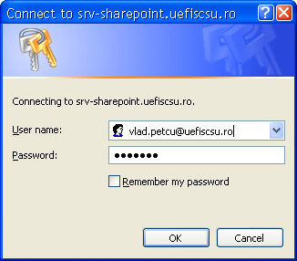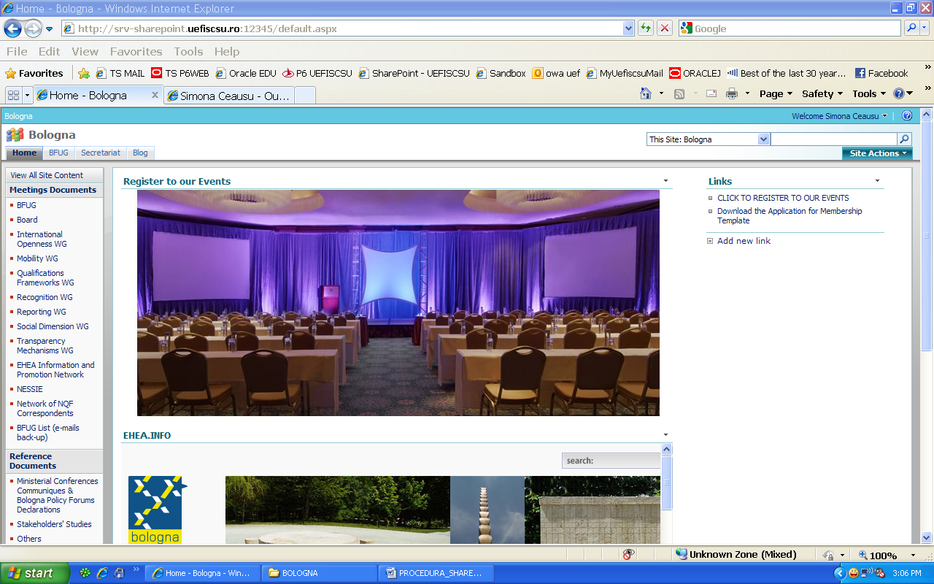
- DOCUMENTS’ MANAGEMENT – LOADING DOCUMENTS

The documents are organized in libraries, accessible from the menu in the left side of the window. They are organized in collections (Meetings Documents, Reference Documents, Communique Drafting, Templates, etc)
To load a document in a library:
- Click on the library name in the left side menu
- Click the upload button
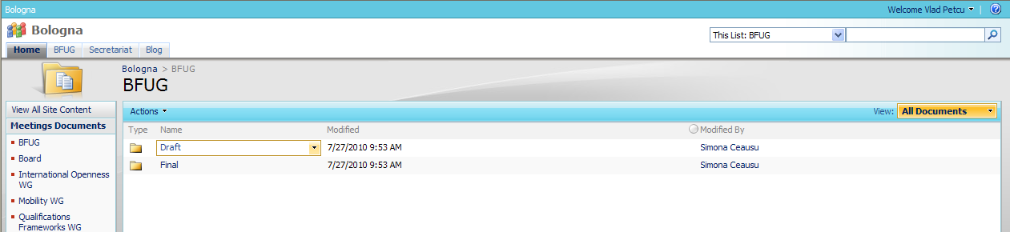
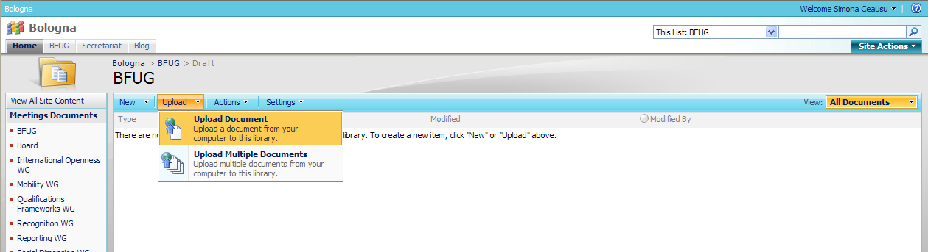
- browse for the document you are looking for
- a comment describing the document can be inserted (optional)
- click “OK”
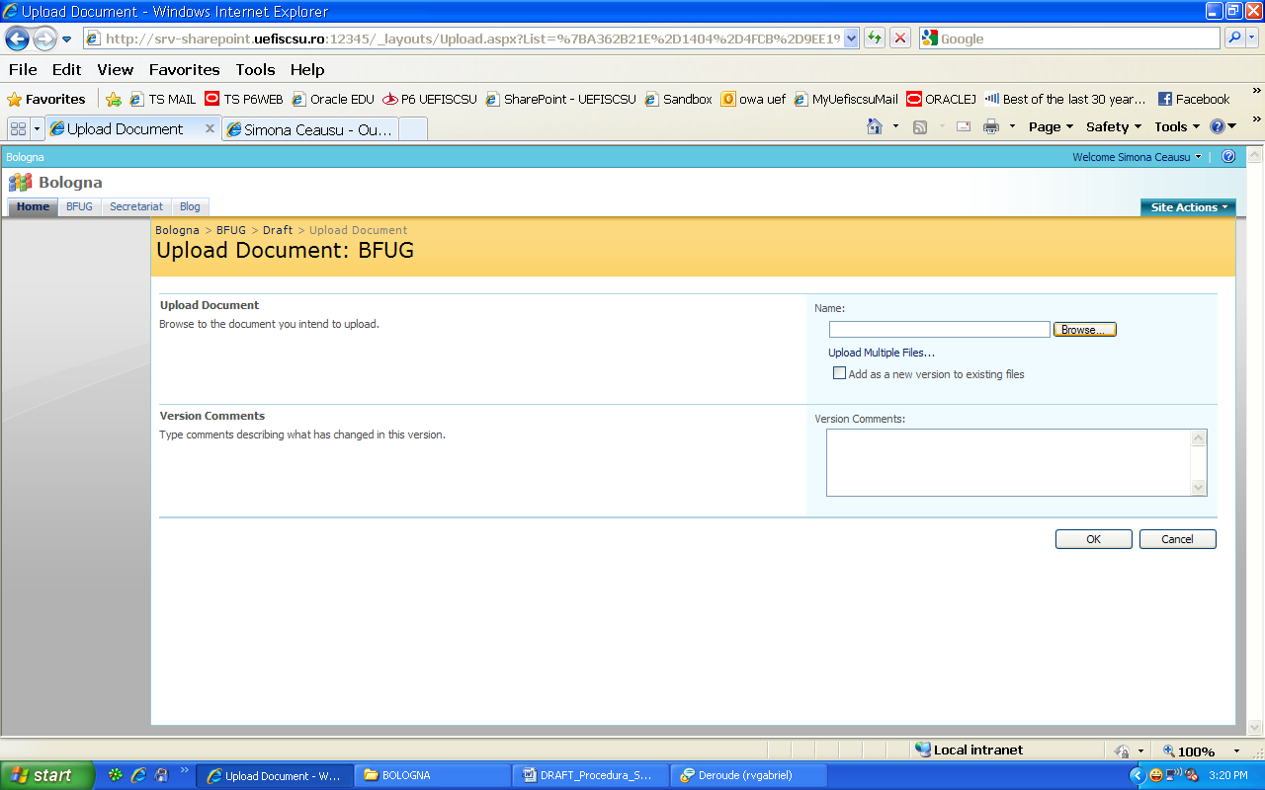
The document will be administrated from the “All Documents” View, contextual menu that joins the document’s name.
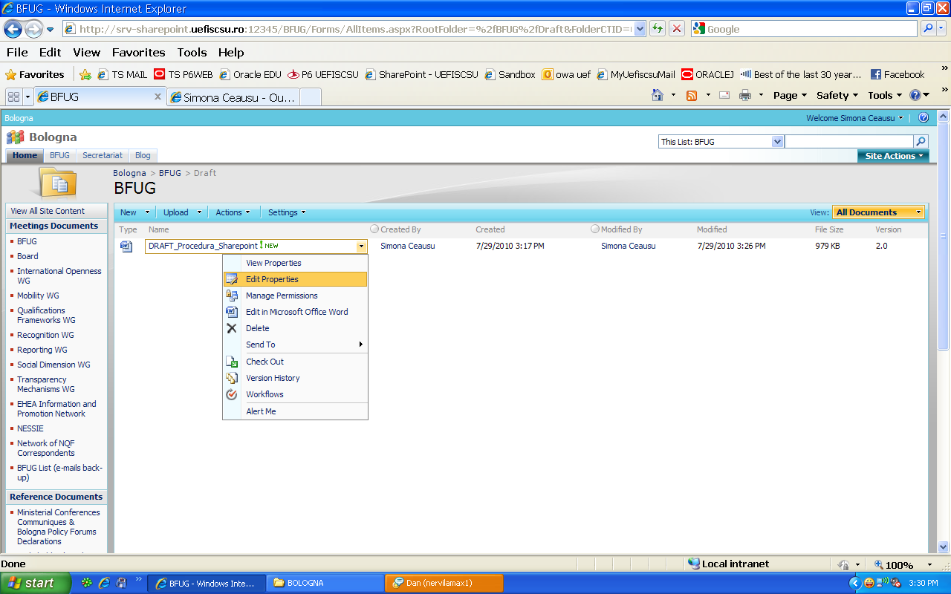

The user is able to configure its own Alert System related to the uploaded document
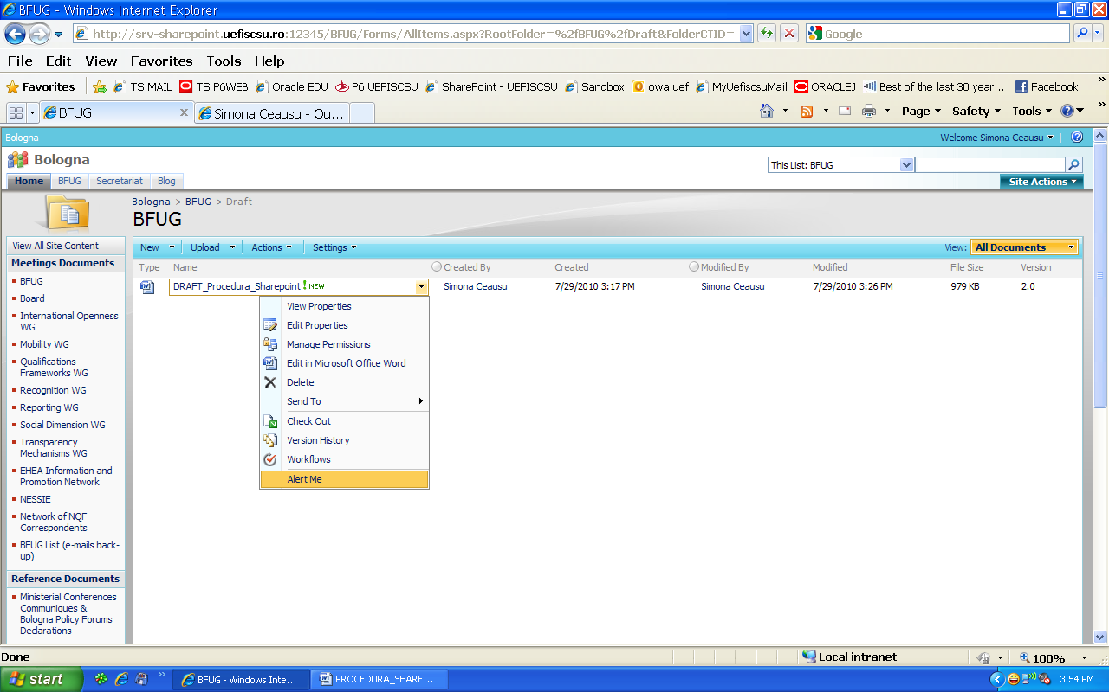
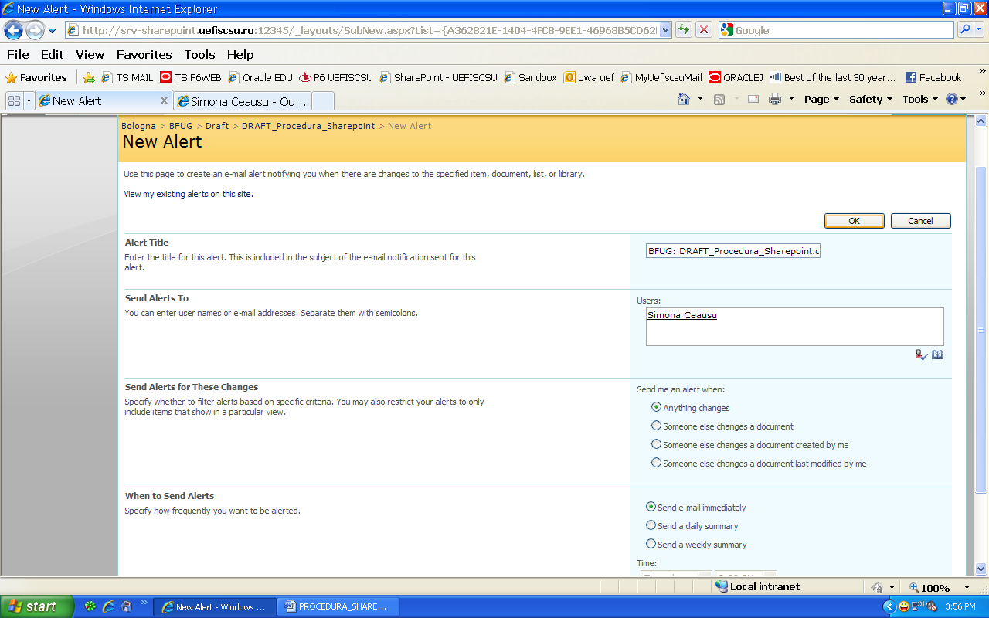
- DOCUMENTS’ MANAGEMENT – EDITING DOCUMENTS

If it is an Microsoft Office Document, it can be directly modified in Sharepoint. Otherwise, you have to choose from the contextual menu “Send To, Download a Copy” to edit locally and then to re-upload the edited version
For the Microsoft Office documents, you have to click on the document’s name and choose the “Edit” option from the pop-up window. 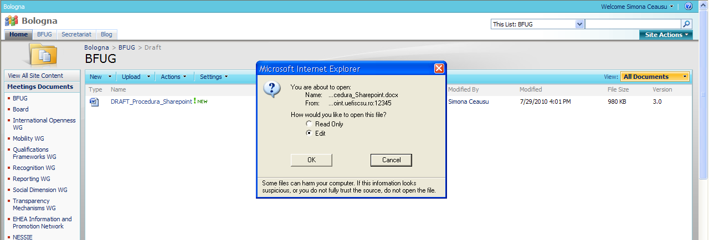

For documents in other formats than Microsoft Office:
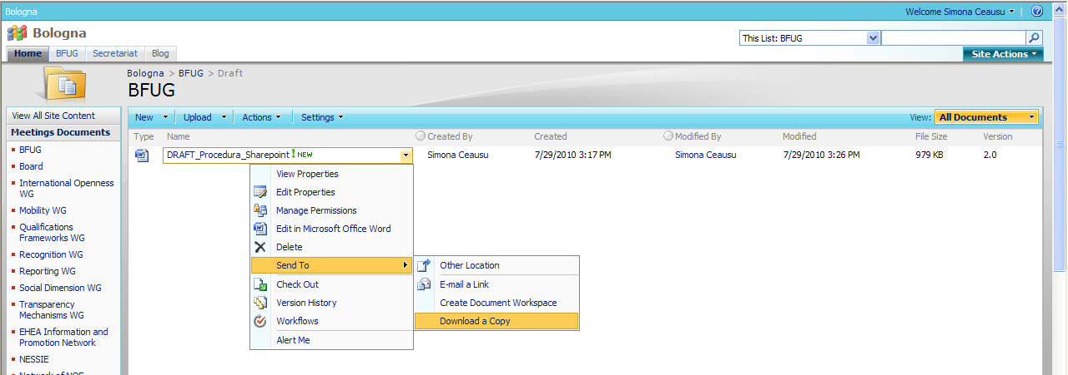
In order to add a new version of a non-Microsoft Office document, after locally editing it, you shall upload it using the “Upload” option from the library menu, making sure to tick the “Add as a new version to existing files” option.
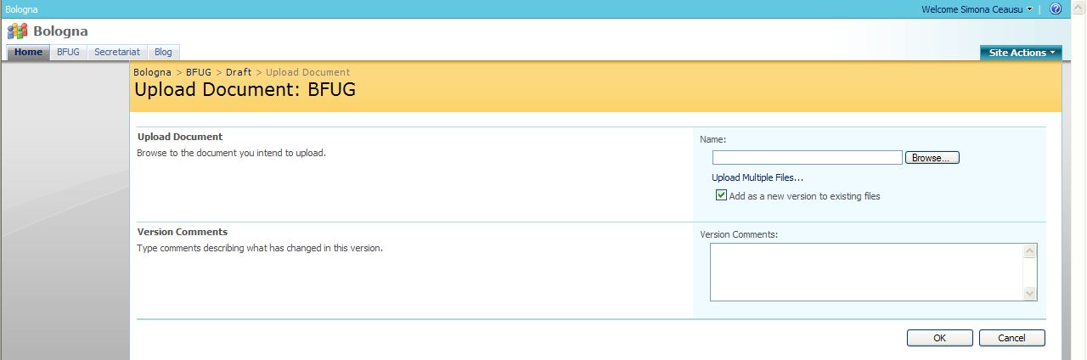
Version history. The set/evolution of a document’s different versions can be checked at any time, using the “Version History” option, from the contextual menu of the document
Any older version may be visualized, and also be set as the current version.
A version is created when one user is saving the changes made in the document. This user appears in the “Modified by” field, from the documents’ view option.
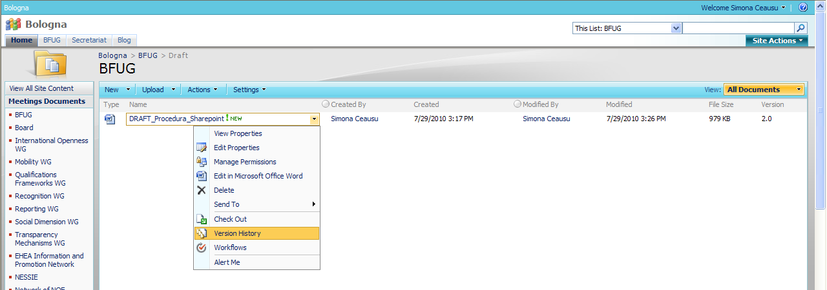
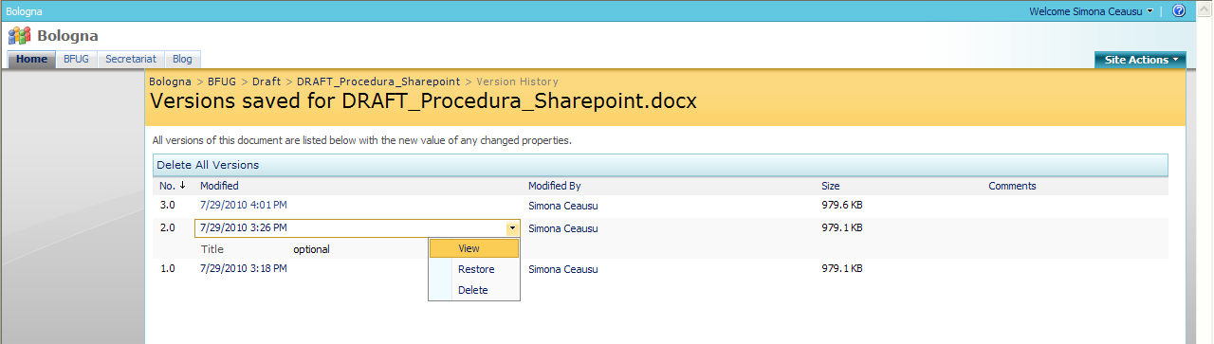
- CONTACTS’ MANAGEMENT – ADDING A NEW CONTACT

- Click on the “Contacts Database” button in the Databases Library.

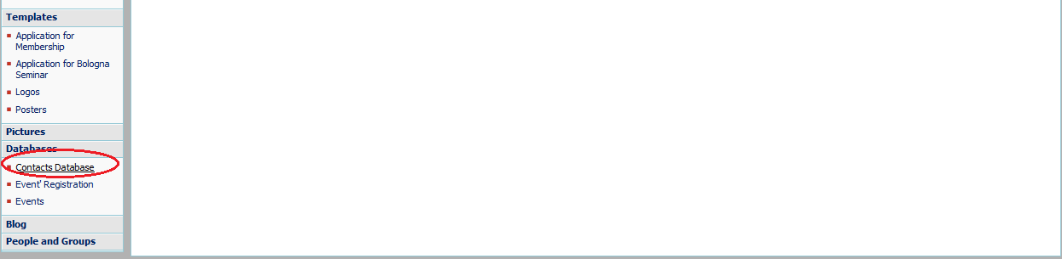
- Click on the “New” button and select “New Item”.
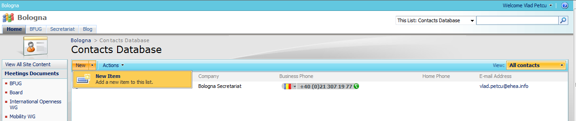
- Fill in the details of the new contact.
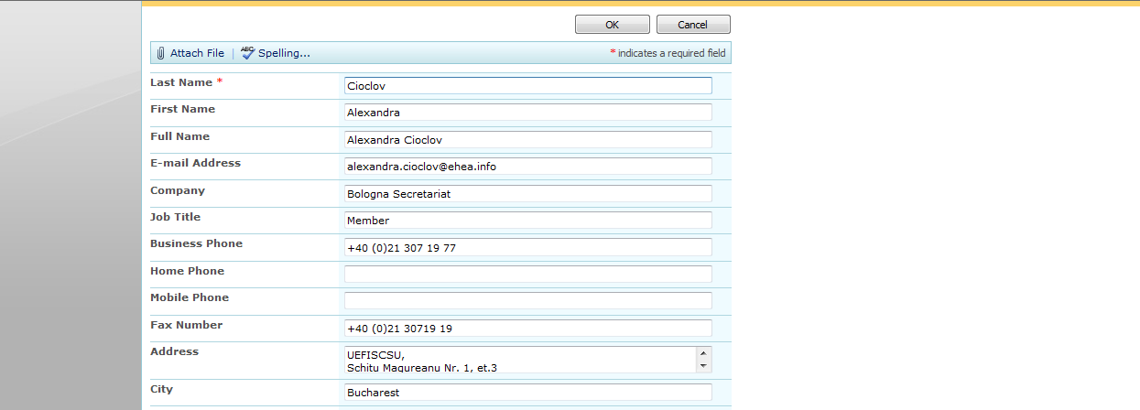
- CONTACTS’ MANAGEMENT – VIEWING THE CONTACTS

- You can sort the contacts’ database on any criteria (exactly like in any Excel table).
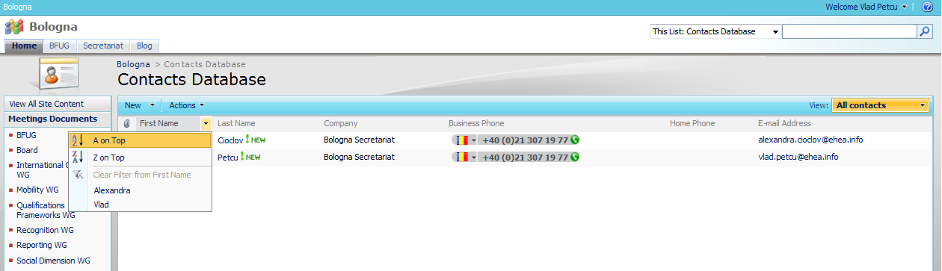
- You can select one of the different viewing templates or you can create your own view.
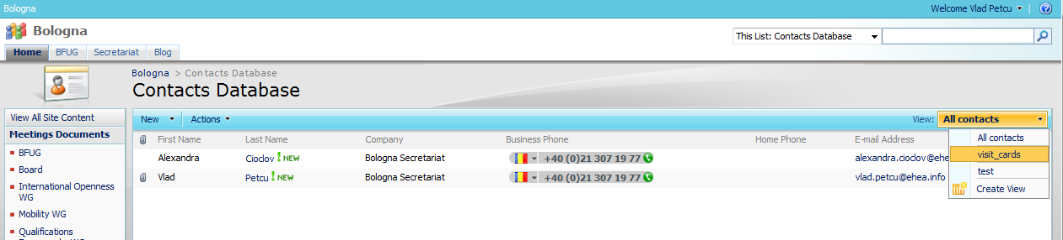
- EVENTS’ REGISTRATION – REGISTER TO AN EVENT

- Click on the “Events’ Registration” button from the “Databases” Library.
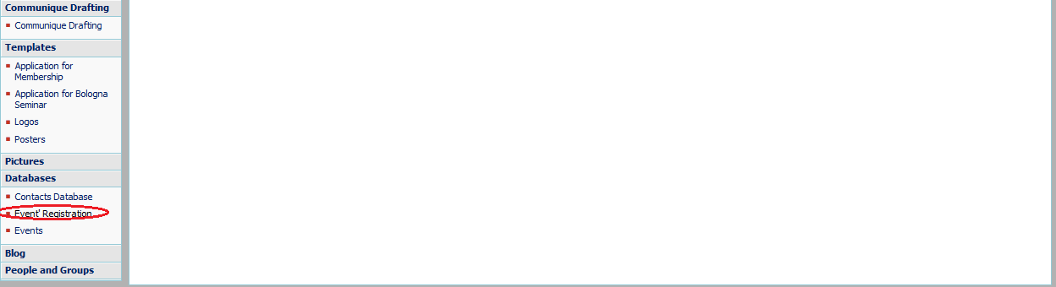
- Click on the “New” button and select “New Item”.
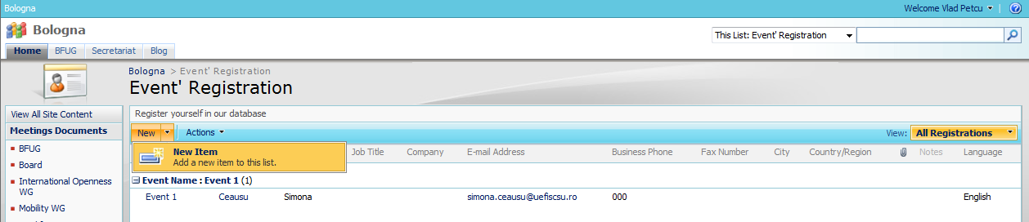
- Select the event you want to register for from the drop-down menu. Fill in the details required for the registration.
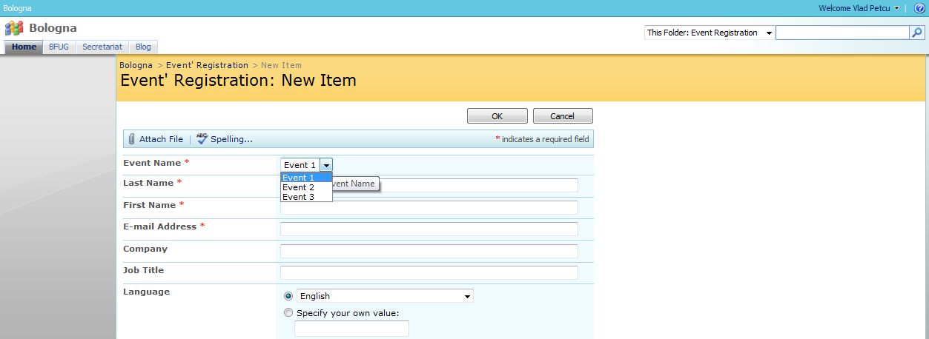
- EVENTS’ REGISTRATION – VIEW REGISTRATIONS

- Click on the “Events’ Registration” button from the “Databases” Library.
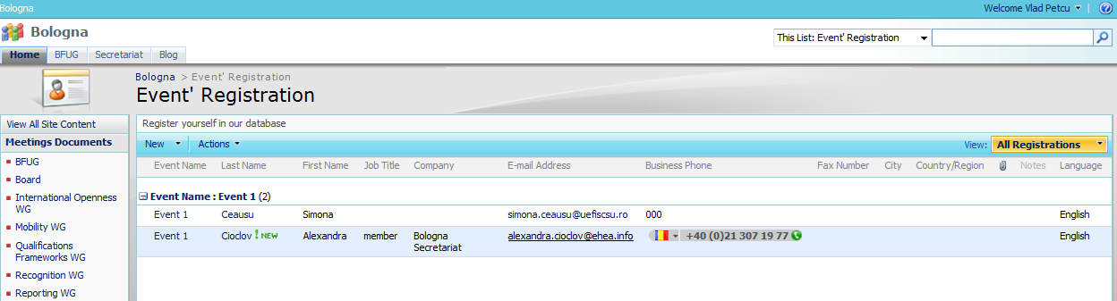

- You can set an alarm linked to a registration from the registration list, following these steps:
  - Click on the contextual menu that joins the registration’s name;
  - Select the “Alert Me” button;
  - Set the Alert as you wish.
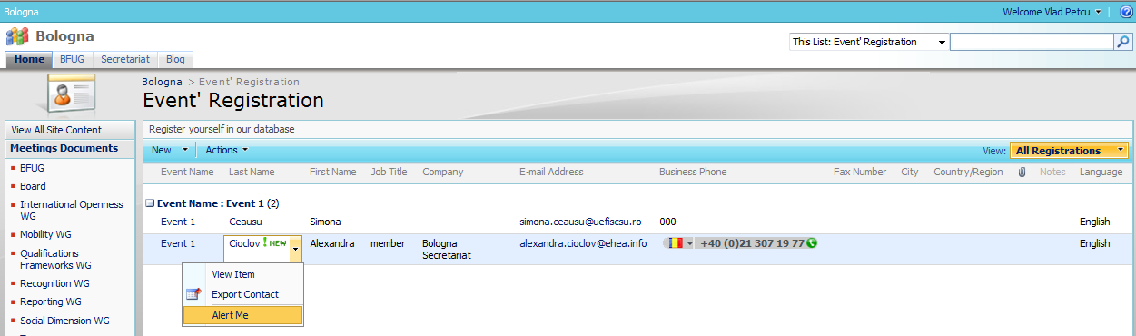
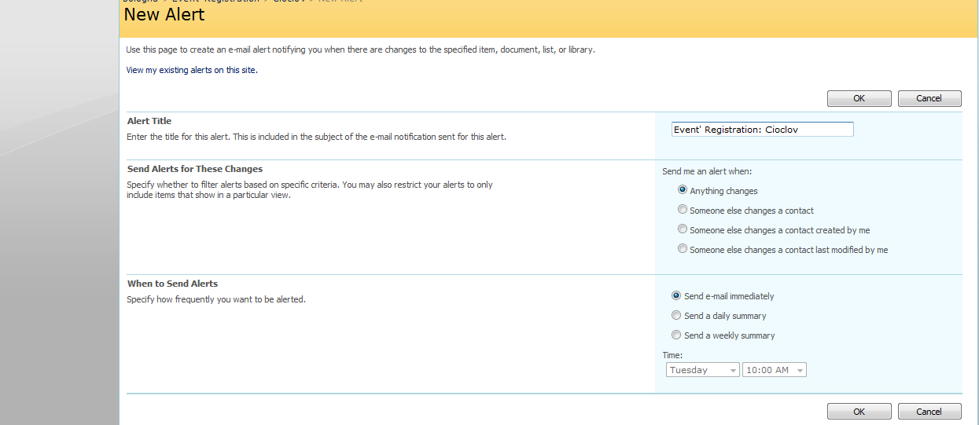
- GANTT

- Click on the “Tasks” button from the “Lists” Library
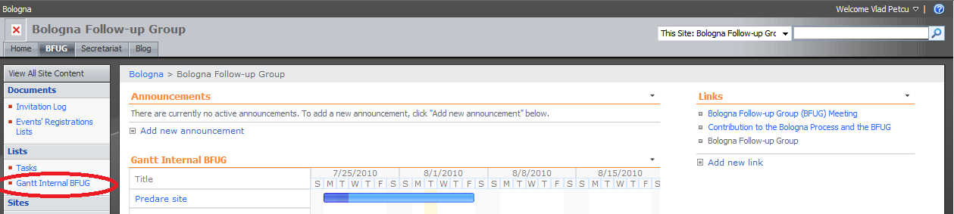
- In order to create a new gantt chart, click the “New” button and select “New Folder”.
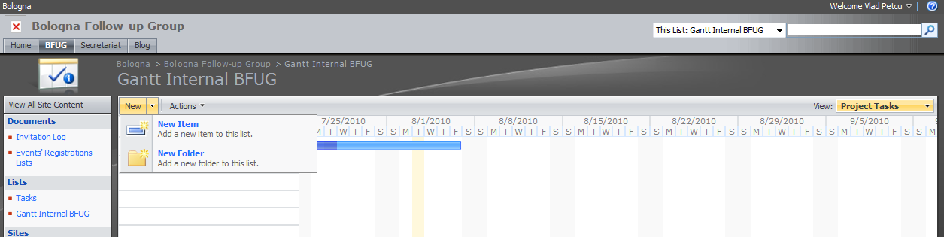
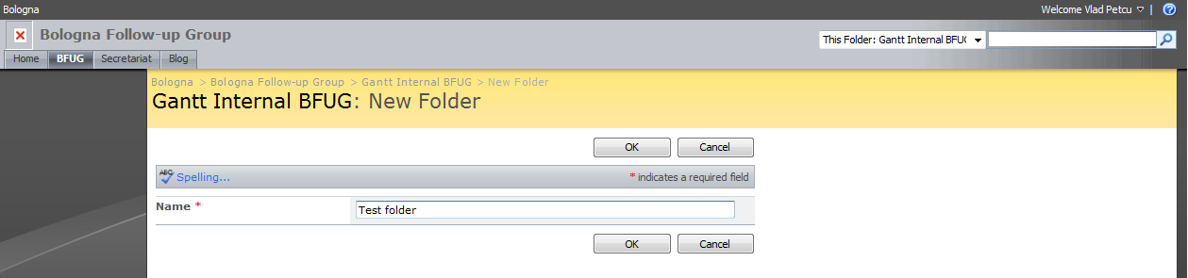
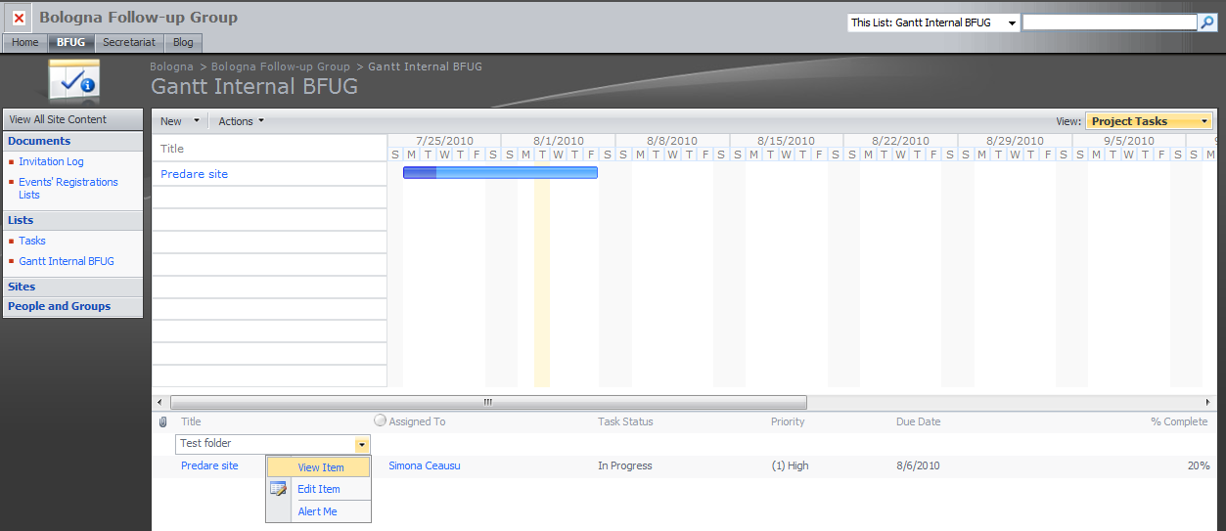
- In order to create a new activity in the chart, click the “New” button and select “New Document”.
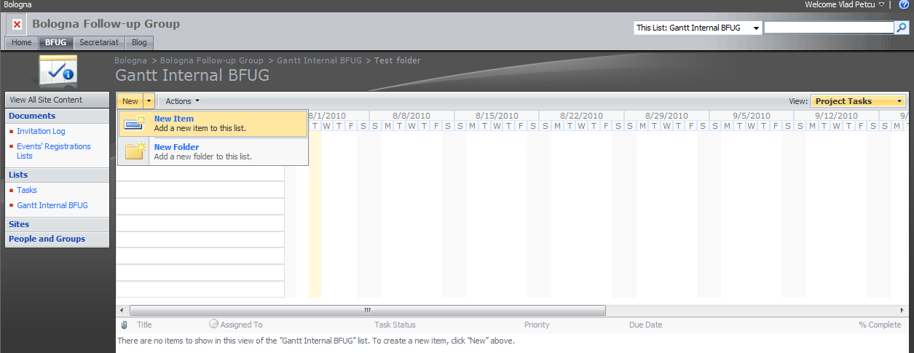
- Fill in all the details regarding the new activity.
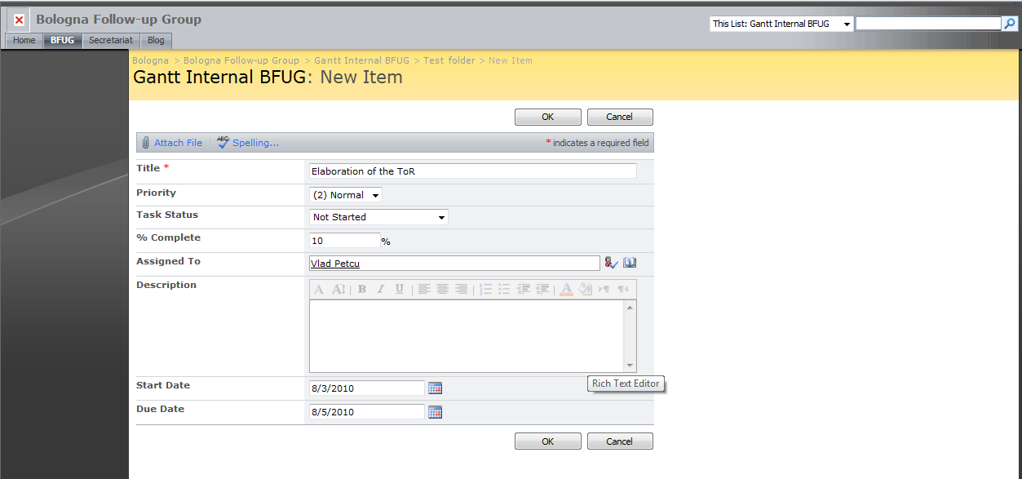
- Click OK and the new activity is shown on the gantt chart.
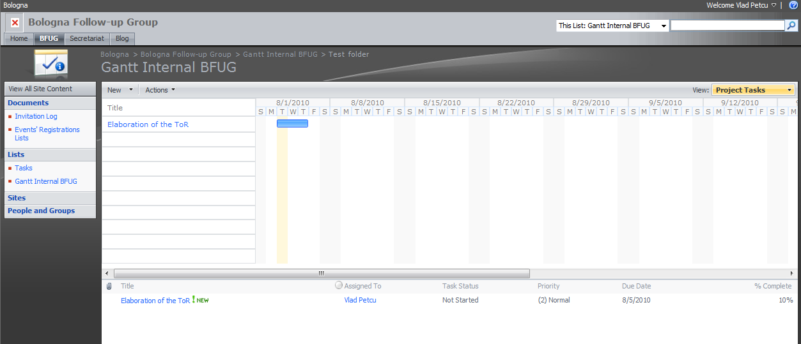
- INVITATION LOG

- Click on the “Invitation Log” button from the “Documents” Library
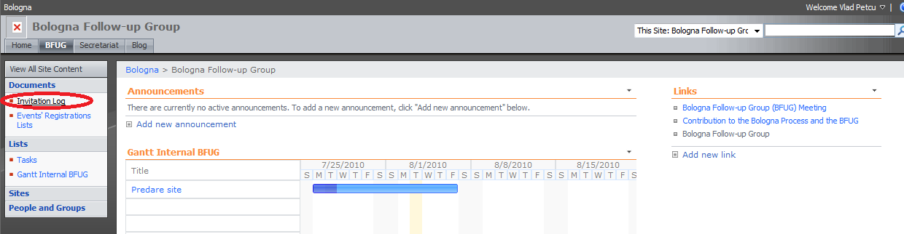
- Select a date in the Calendar and click the “New” button and select “New Document”.
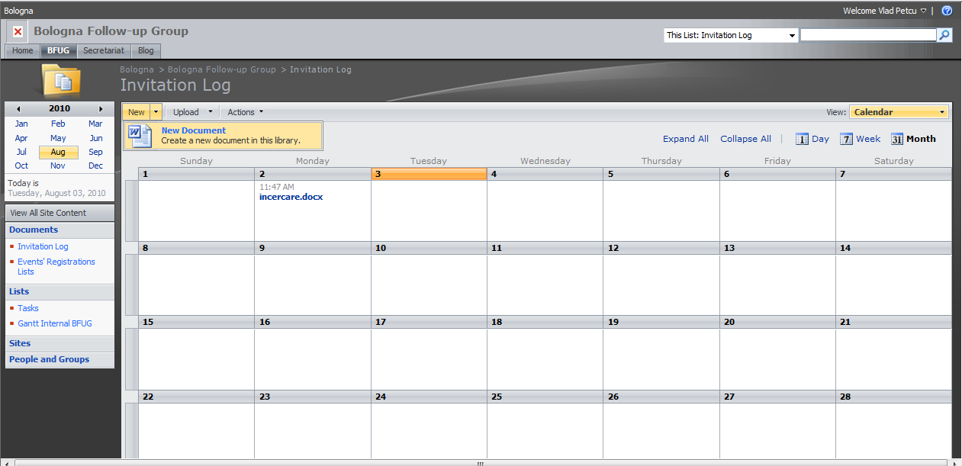
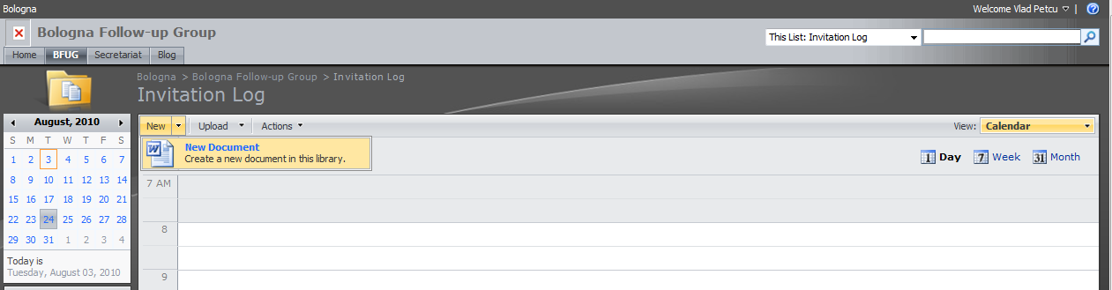
- To upload a document, you have to click on the “Upload” button and select
  - “Upload Document”, in order to upload a single document
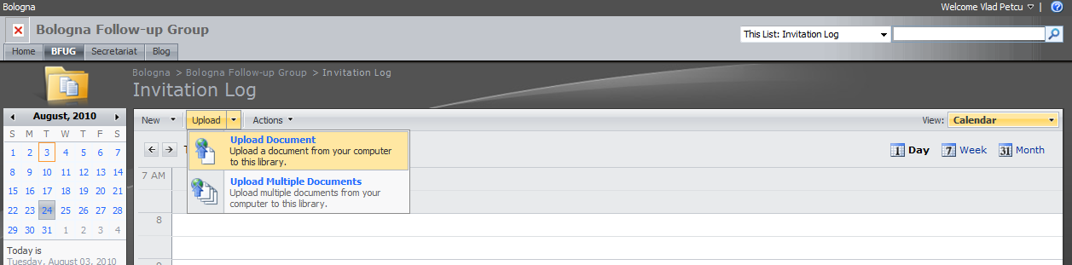
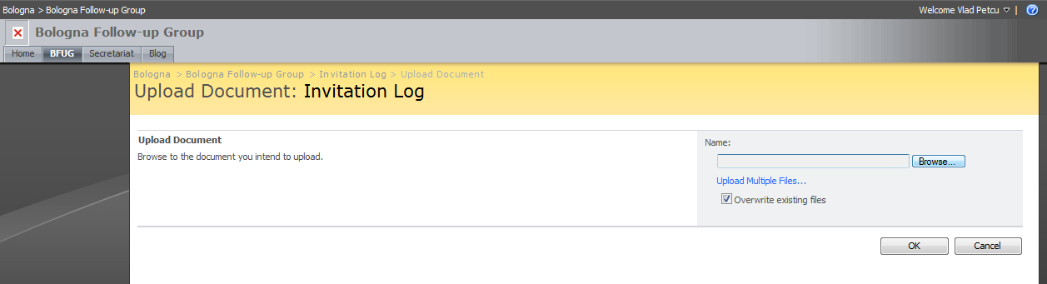
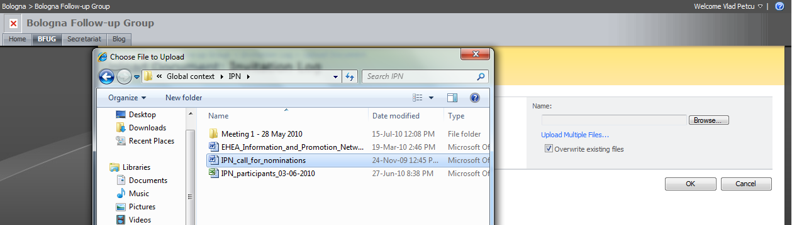
  - “Upload Multiple Documents”, in order to upload multiple documents.
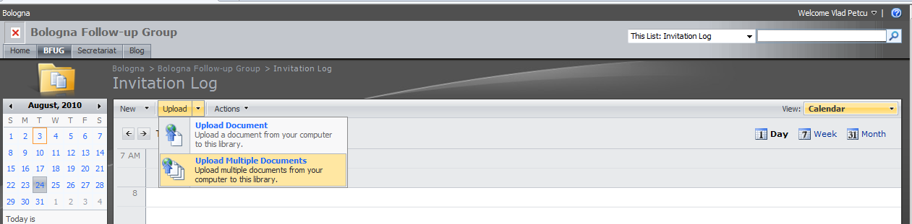
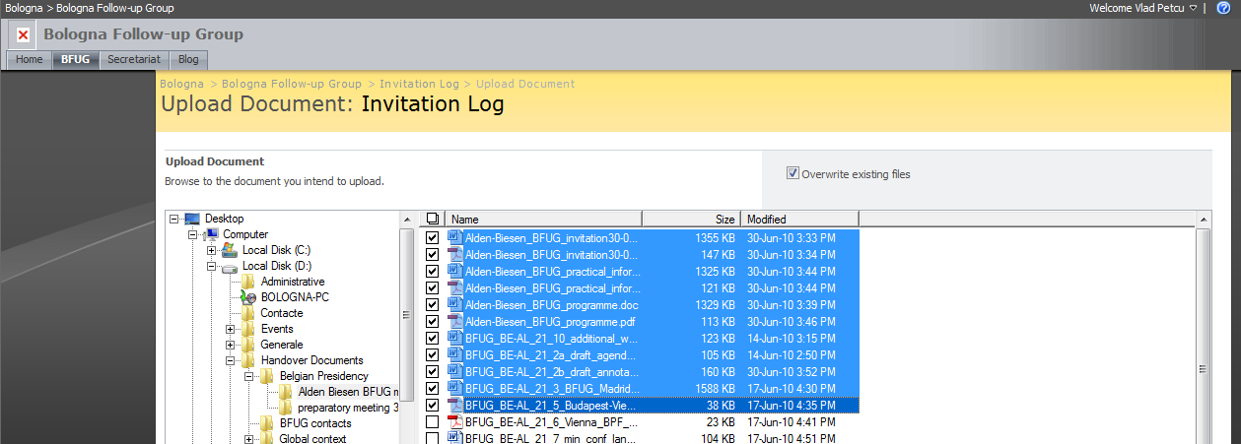
- To change the view, you have to click the “View” button and select the view you want or create a new one.
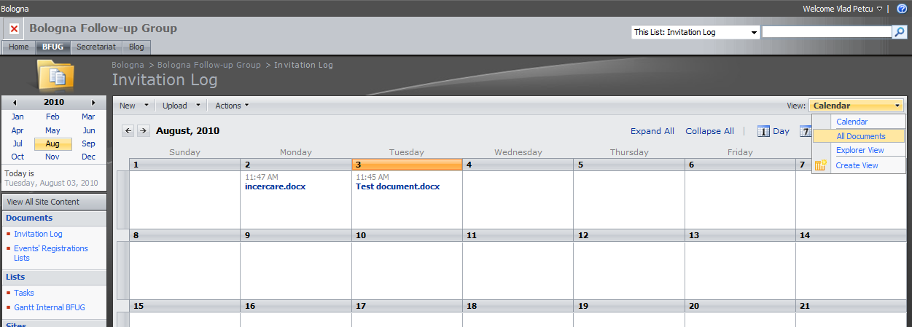
- In order to work with the documents uploaded, please refer to the “Documents’ Management” tutorials – Chapters II and III.
- TASKS

- Click on the “Tasks” button from the “Lists” Library
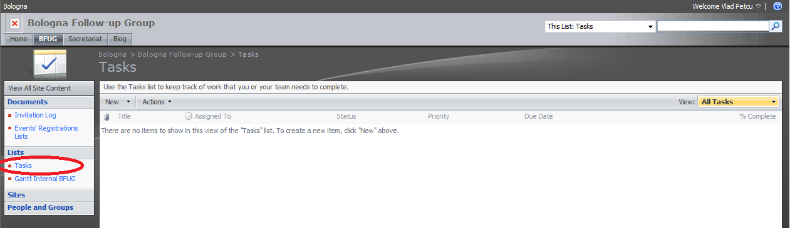
- Click on the “New” button and select “New Item”
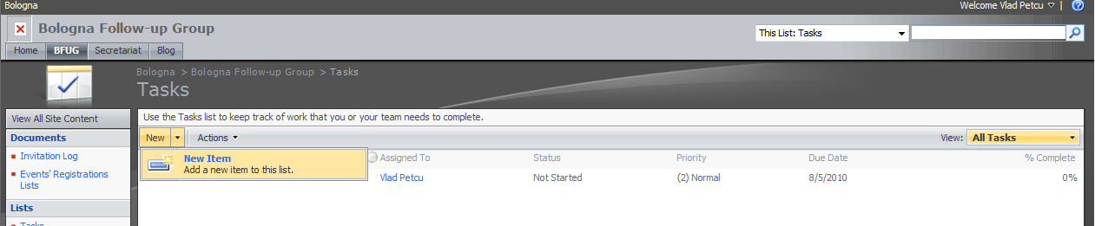

- Fill in the details of the task and assign it to the person responsible for it.
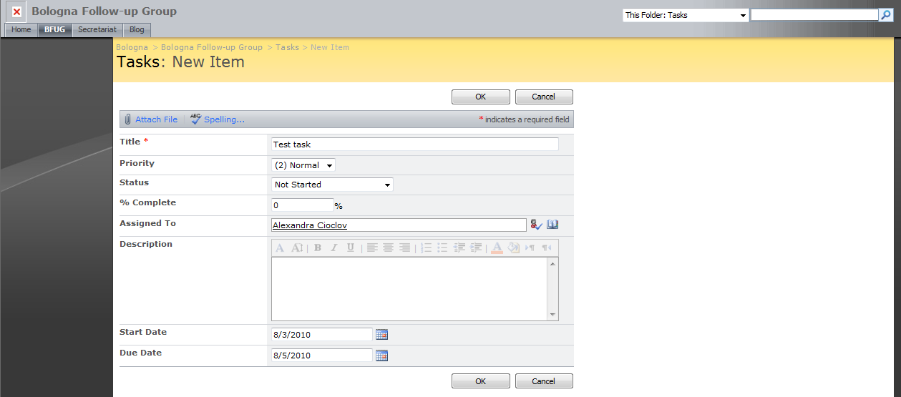
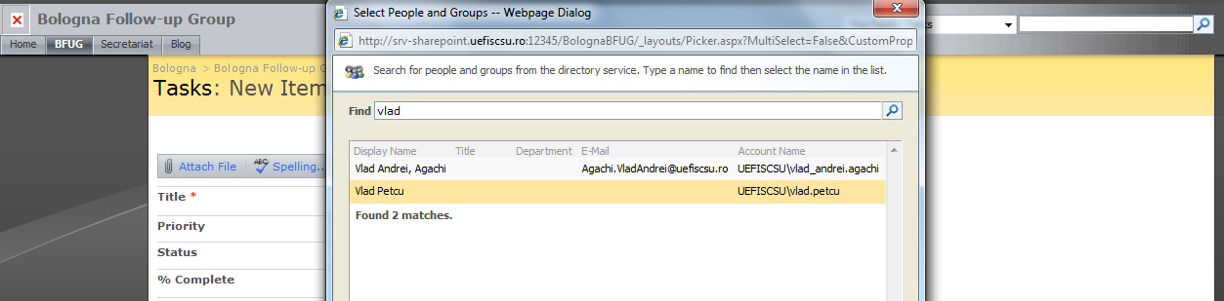

- You can change the view by clicking the “View” button.
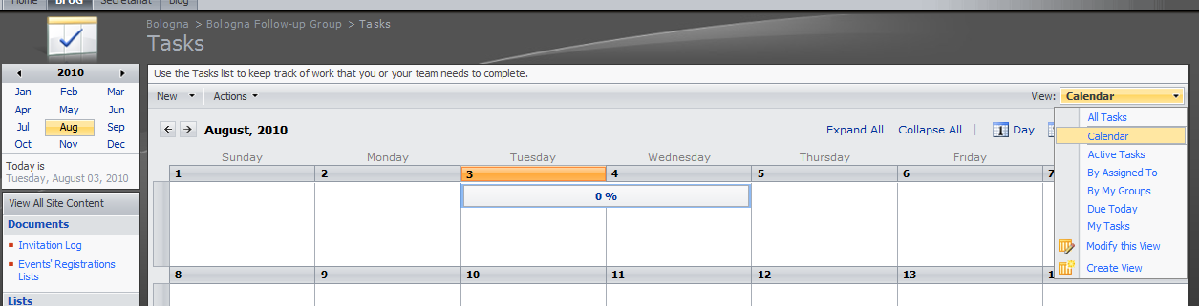

Tutorials for the members and WGs/Networks public editable content

- Access the page http://www.ehea.info/member-login.aspx
- Fill in the username and password with the data provided by the Bologna Website Administrator. You will be logged in.
- After being logged in the link to the administrative interface for the working group page will be available, as you can see in the picture below.
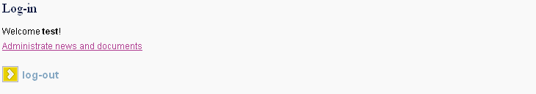
- By clicking the link you will be redirected to the administrative interface. This interface is displayed in the following image.
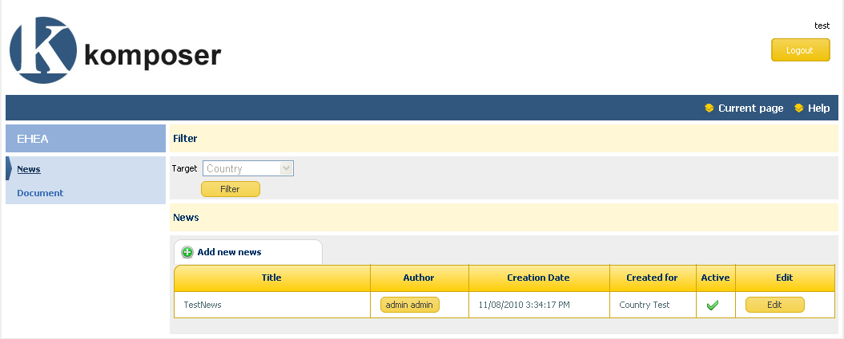
- This interface will allow you to enter news and documents that will be displayed on your working group page.
- Add new news:
  - Press the Add new news button
  - The following page will be displayed
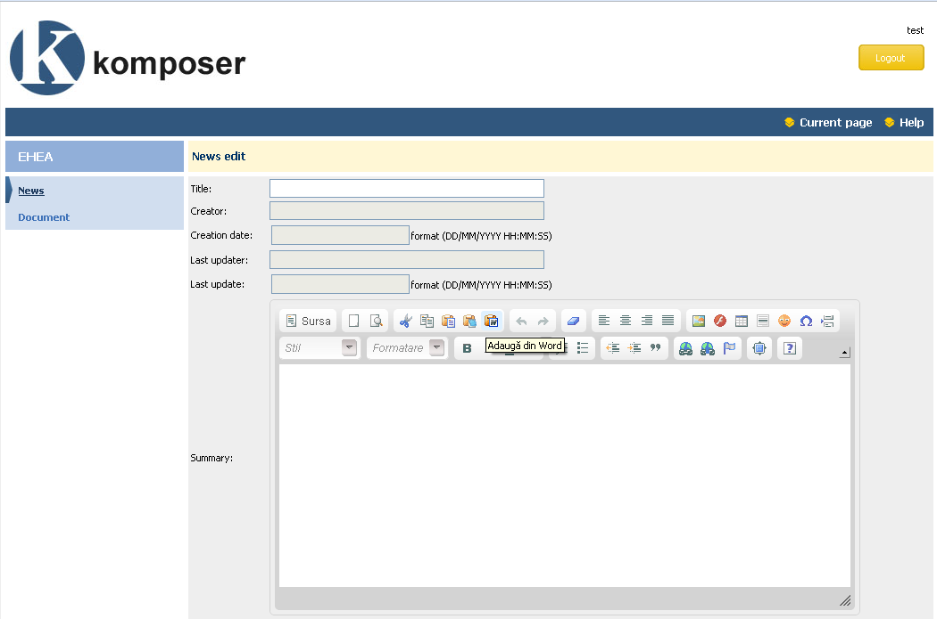
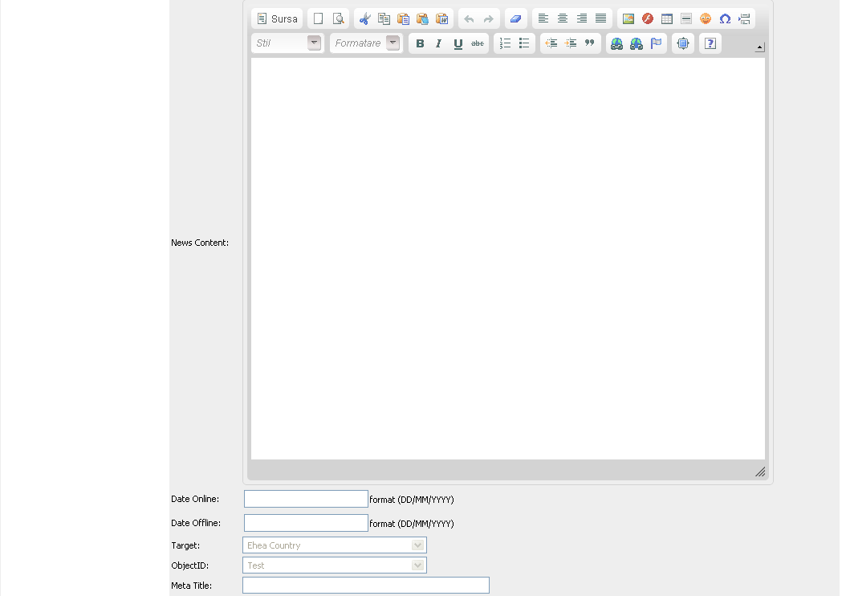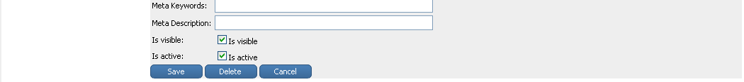
  - You will have to enter the Title of the News, it’s summary(a short description of the news), the content of the news, Date Online(the date starting with which the news will be online), Date Offline(starting with this date the news will no longer be visible), Meta Title, Meta Keywords, MetaDescription(the meta fields are used for SEO purposes; the values entered in this fields will be displayed as meta information on the page displaying the news allowing it to be indexed by this meta ). Check the is visible and isactive checkboxes in case that you want this news to be visible on the site. Unchecking the is visible and isactive checkboxes will prevent the news from being displayed on the page of the working group. After filling in all the information press the save button in order to save changes.
  - For the summary and content of a news the interface provides a What You See Is What You Get Editor enabling you to enter directly html content for this fields. For a detailed documentation on how to use this editor please consult the following link http://docs.cksource.com/FCKeditor_2.x/Users_Guide .

- Edit an already existing news:
  - In the News page (listing all the news) press the Edit button, from the central table listing all the news , for the news that you want to edit.
  - You will be redirected to the detail page of a news. The content of this page has been explained in the above point on how to add a new news. After having done all the necessary changes for that particular news press the Save button.
- Delete a news:
  - In the News page (listing all the news) press the Edit button, from the central table listing all the news , for the news that you want to edit.
  - You will be redirected to the detail page of a news. Press the delete button from the bottom of the page.
- The Documents page lists all the documents displayed on the working group page. This page can be accesed by clicking the Document link from the left menu. The following interface will be displayed.
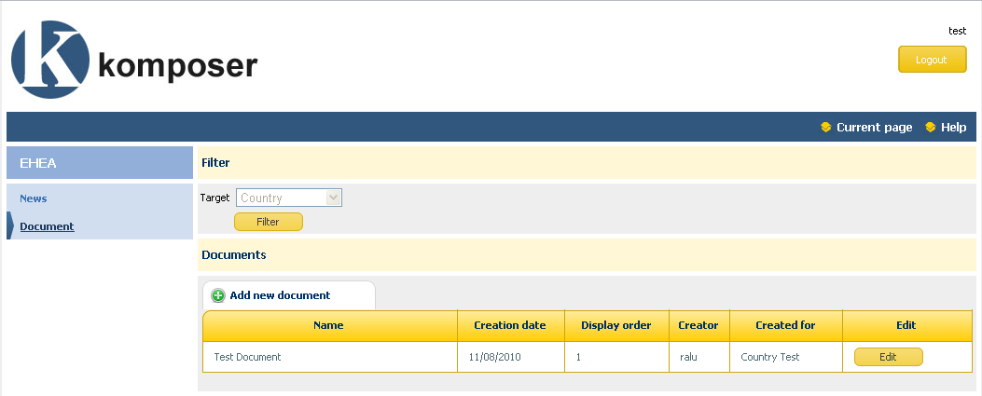
- Add new document:
  - Press the Add new news document
  - The following page will be displayed
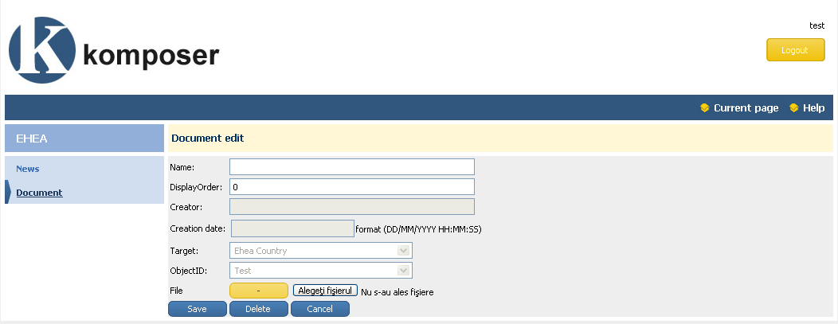
  - You will have to enter the name of the document, the display order number(documents will be displayed on the working group page according to the display order). In order to upload a document press the “Alegeti fisierul” button (according to the browser language the name of the button can be different: in Romanian it is “Alegeti fisierul”, in English “Upload File”).
- Edit an already existing document:
  - In the Documents page (listing all the documents) press the Edit button, from the central table listing all the documents, for the document that you want to edit.
  - You will be redirected to the detail page of the document. The content of this page has been explained in the above point on how to add a new document. After having done all the necessary changes for that particular document press the Save button. You can also see the already uploaded file by pressing the Open File button.
- Delete a document:
  - In the Documents page (listing all the documents) press the Edit button, from the central table listing all the documents, for the document that you want to edit.
  - You will be redirected to the detail page of the document. Press the delete button from the bottom of the page.

Templates for National pages and WGs/Networks pages

Template national pages

- Country flag Country name (EN)/national language
- Responsible national authority:
- Higher education institutions (list):
- Academic recognition body/ bodies:
- National students’ organisation:
- National Rectors’ Conference:
- National Teachers’ representatives organisation:
- National Employers’ representatives organisation:
- EU education programmes’ contact person:
- Information about the Bologna Process/ National Implementation:
- Full member of the Bologna Process since …..
- National reports on Bologna reforms
- Representatives in the Bologna Follow-up Group:
- Contact person (for the Bologna Policy Forum):

Template WGs/Networks page

- Name of the WG
- Contact person (Chair)
- Composition all info can be found in the Terms of Reference
- Purpose and/or outcome
- Specific tasks
- Last update of work, previously approved by the BFUG
- Public area – various info, at the choice of the WG/Network

“Report on the development of the European Higher Education Area. Background paper for the Bologna Follow-up Group prepared by the Benelux Bologna Secretariat” for the Leuven/Louvain-la-Neuve Ministerial Conference, 28-29 April 2009

