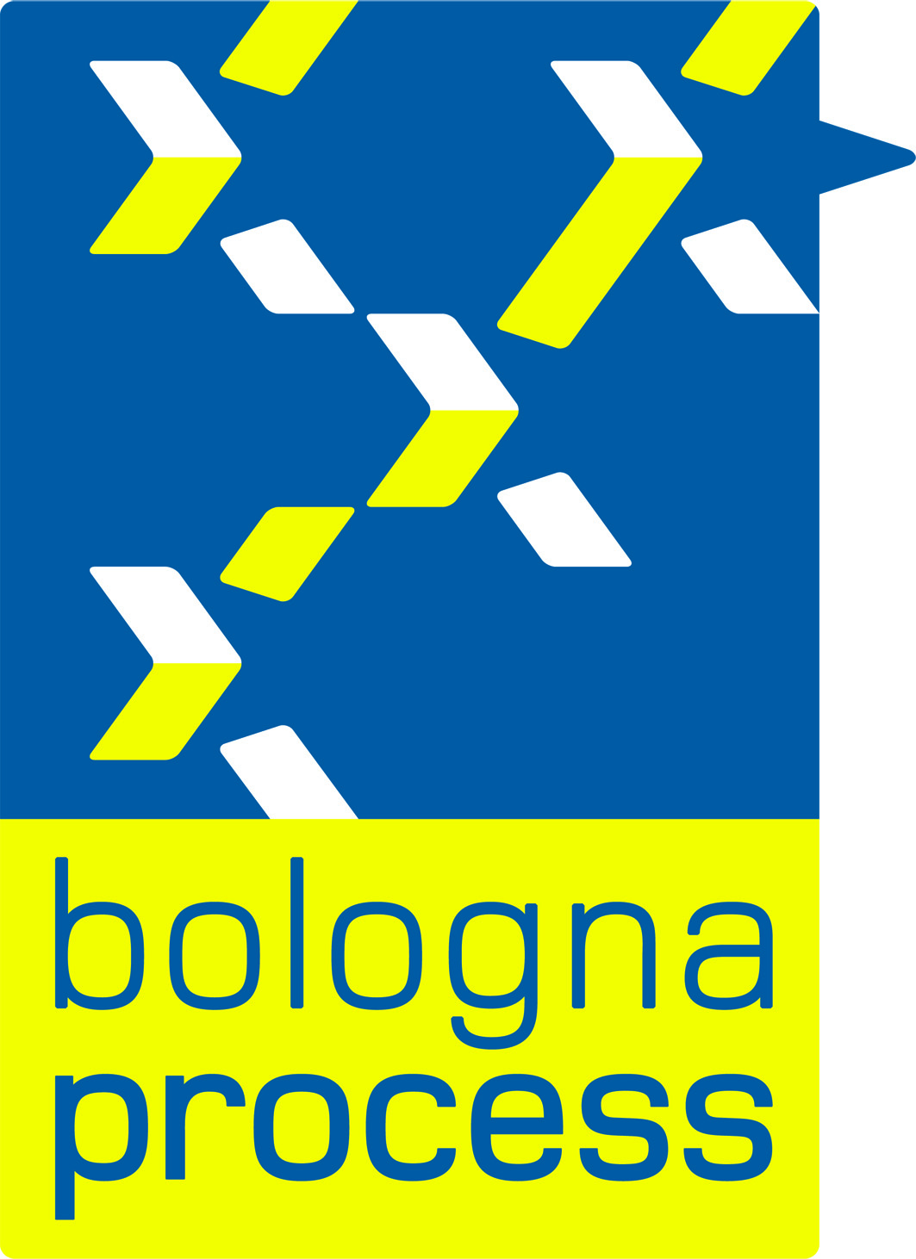


BFUG (BE/AL) 21_2a
Issue date: 01/08/2010

MEETING OF THE BOLOGNA FOLLOW-UP GROUP

Alden Biesen, 24 August 2010, 9.30 hrs -25 August 2010, 12.30 hrs

Draft agenda

Welcome and introduction to the meeting
- Information by the Chairs (Belgium & Albania)
- Adoption of the agenda
- Outcome of proceedings of the BFUG meeting, Madrid,
18-19 February 2010
- Information by the Bologna Secretariat & presentation of the EHEA website
- Feedback on the Budapest/Vienna Ministerial Conference
- Feedback on and follow-up to the Second Bologna Policy Forum
- Proposal for written procedure on language regime for ministerial conferences
- Criteria for accession to the European Higher Education Area
- Leuven/Louvain-la-Neuve agenda / 2009-2012 Work Plan
  - Reporting on the Implementation of the Bologna Process
  - Mobility
  - Recognition
  - Social Dimension
  - Network of Experts in Student Support in Europe (NESSIE)
  - International Openness
  - Qualifications Frameworks
  - Transparency Mechanisms
  - RPL Network
- Brainstorming on additional working methods
- Information on ECTS
- Updates from EC, consultative members, EQAR (written contributions only)
- Next BFUG meeting, Hungary (exact place tbc), 17-18 March 2011
- Any other business

