BFUG (BE/AL) 21_12a

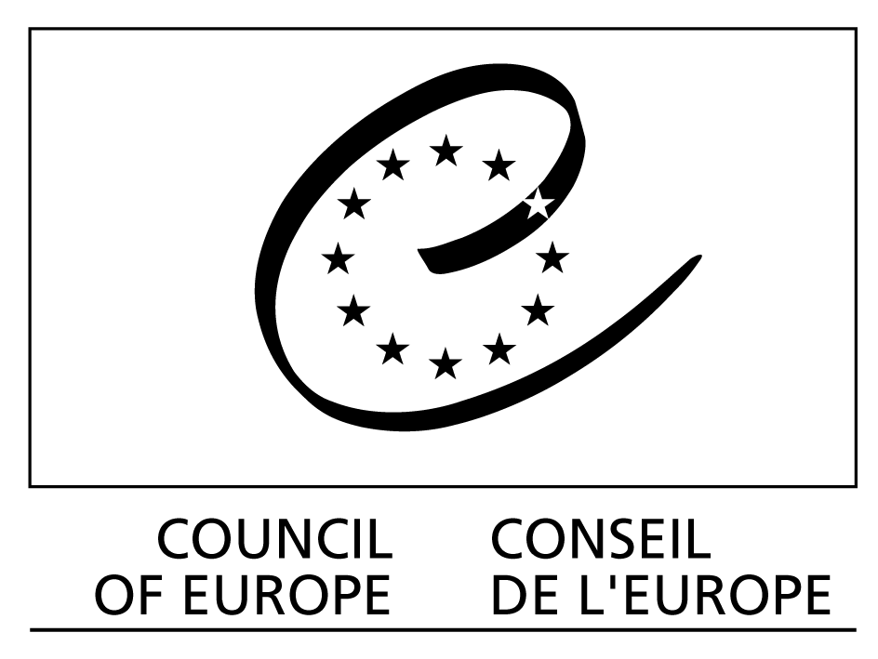

Orig. Eng.
Strasbourg, July 16, 2010

Bologna Follow Up Group

Alden-Biesen, August 24 – 25, 2010

THE CONTRIBUTION OF THE COUNCIL OF EUROPE TO THE BOLOGNA PROCESS 2010 - 2012

Directorate General IV: Education, Culture and Heritage, Youth and Sport
(Directorate of School, Out-of-School and Higher Education/Higher Education and Research Division)

Distribution: BFUG
General
Document available on http://www.coe.int/DGIVRestricted

INTRODUCTION

The present document gives an overview of the Council of Europe’s contribution to the Bologna Process between the Ministerial meetings in Budapest/Wien in March 2010 and Bucureşti in April 2012.

Over the past years, the Council of Europe contributions to the Bologna Process have focused on:

- active participation in the BFUG and Board as well as in working groups;
- take responsibility for coordinating the sharing of experience in the elaboration of national qualifications frameworks compatible with the overarching framework of qualifications of the EHEA, inter alia by chairing and providing the Secretariat for the Bologna Coordination Group on Qualifications Frameworks and participating in the work of the EQF Advisory Board;
- recognition policy, including the role of the Lisbon Recognition Convention as the only legally binding text of the Bologna Process;
- specific policy areas of relevance to the Bologna Process as well as to the basic values of the Council of Europe, in particular the public responsibility for higher education and research, the responsibility of higher education for democratic culture, higher education governance and quality assurance;
- bilateral and regional activities assisting newer member states with the implementation of “Bologna inspired” policies at national level. These activities have in particular focused on countries that acceded to the Bologna Process in 2003 and later.

The Council of Europe intends to continue to contribute to the Bologna Process along these lines. Currently, in addition to chairing the working group on qualifications frameworks, the Council of Europe contributes to the working groups on recognition, international openness and transparency instruments.

QUALIFICATIONS FRAMEWORKS

The role of the Council of Europe is to facilitate the sharing of experience so that the competent national authorities can benefit from relevant experience from other countries to the extent that the national authorities see fit to do so. This is in keeping with the London Communiqué:

We note that some initial progress has been made towards the
implementation of national qualifications frameworks, but that much more effort is required. We commit ourselves to fully implementing such national qualifications frameworks, certified against the overarching Framework for Qualifications of the EHEA, by 2010. Recognising that this is a challenging task, we ask the Council of Europe to support the sharing of experience in the elaboration of national qualifications frameworks. We emphasise that qualification frameworks should be designed so as to encourage greater mobility of students and teachers and improve employability.

as well as with the Leuven/Louvain-la-Neuve Communiqué:

The development of national qualifications frameworks is an important step towards the implementation of lifelong learning. We aim at having them implemented and prepared for self-certification against the overarching Qualifications Framework for the European Higher Education Area by 2012. This will require continued coordination at the level of the EHEA and with the European Qualifications Framework for Lifelong Learning. Within national contexts, intermediate qualifications within the first cycle can be a means of widening access to higher education. (para. 12).

A separate update on the activities related to qualifications frameworks is submitted to the BFUG and will not be repeated here except to underline the main points:

- the national correspondents met in Dublin in April and will meet again in Strasbourg in October;
- the working group met in Bruxelles in June and will meet again in Strasbourg in October;
- an updated survey of the development of national qualifications frameworks will be provided in autumn;
- cooperation with the European Commission, responsible for the EQF-LLL, remains excellent and in October, the meeting of national correspondents will be held jointly with the national contact point for the EQF-LLL.

RECOGNITION OF QUALIFICATIONS

The Council of Europe/UNESCO Recognition Convention is the only legally binding text of the Bologna Process. As of July 16, 2010, all EHEA members except Greece and Italy had ratified the Convention; Greece had also not signed the Convention. The total number of ratifications – including non-members of the Bologna Process – is now 50, while three further countries – including Italy – have signed but not yet ratified it. The development of policy and practice in recognition is furthered by the ENIC and NARIC Networks, which are served jointly by the Council of Europe, UNESCO/CEPES and the European Commission.

The Council of Europe will continue to play a leading role in recognition policy, in close cooperation with UNESCO and the European Commission. Recognition issues in the Bologna Process will remain high on the agenda of the ENIC and NARIC Networks, which – through their connection to other UNESCO regions – will also play an important role in facilitating recognition between qualifications from the EHEA and those from other areas of the world, and the Networks have established a working group to address this topic, for which the Council of Europe provides the secretariat.

The ENIC and NARIC Networks will continue to consider the impact of qualifications frameworks on the recognition of qualifications, and qualifications frameworks will be an element in developing the understanding of the concept of substantial differences.

The 2010 meeting of the ENIC and NARIC Networks was held on June 20 – 22 in Sèvres and hosted by the French ENIC/NARIC. The Lisbon Recognition Convention Committee met on June 23, also in Sèvres, and adopted a revised Recommendation on Criteria and Procedures for the Assessment of Foreign Qualifications.

STEERING COMMITTEE FOR HIGHER EDUCATION AND RESEARCH

The Steering Committee for Higher Education and Research (CDESR) is a pan-European forum in which delegations of the 50 States party to the European Cultural Convention – 47 of which are also members of the Bologna Process - are made up of academic as well as government representatives. In addition, important intergovernmental institutions as well as non-governmental organizations active in higher education policy have observer status with the CDESR, which is one of the main pan-European fora for higher education policies.

The 2010 CDESR plenary session was held in Strasbourg on March 25 – 26 and Kazakhstan attended for the first time, as a new State Party to the European Cultural Convention. Radu Damian (Romania) ended his term of office as Chair of the CDESR and Virgílio Meira Soares (Portugal) was elected as the new Chair. Germain Dondelinger (Luxembourg) was elected Vice Chair. The CDESR also reviewed a proposal for a new project on the role of public authorities in ensuring academic freedom and institutional autonomy (see below); adopted an opinion on Recommendation 1892 (2009) by the Parliamentary Assembly on “The Contribution of the Council of Europe in the Development of the European Higher Education Area”; the preparation of the 23 session of the Council of Europe’s Standing Conference of Ministers of Education, which was held in Slovenia on June 4 – 5; and the role of higher education in developing intercultural dialogue and democratic culture.

The CDESR was also informed of the ongoing reform of the Council of Europe. While the 2011 budget of the Organization will be adopted in November/December 2010, at the time of writing it seems likely that it will include a proposal to replace the current separate Steering Committees for Higher Education (CDESR) and Education (CDED) with a single steering committee covering all areas of education. A proposal in this sense will be submitted in the course of autumn 2010 and, if adopted, it is likely to take effect as of 2011.

PARLIAMENTARY ASSEMBLY

The Council of Europe’s Parliamentary Assembly is made up of representatives of the national parliaments of the Council’s 47 member states As BFUG members will know, it adopted Recommendation 1892 (2009) on “The Contribution of the Council of Europe in the Development of the European Higher Education Area” in late 2009 and, as mentioned above, the CDESR gave its opinion to its 2010 plenary session. The Committee of Ministers has yet to adopt the Council of Europe’s position on this Recommendation.

CONFERENCE ON ACADEMIC FREEDOM AND UNIVERSITY AUTONOMY

As mentioned above, the Council of Europe will launch a new project on “Academic Freedom and Institutional Autonomy: the Role of Public Authorities” on the basis of a feasibility study written by professor Pavel Zgaga. The Magna Charta Observatory was also closely involved with the feasibility study and will be a part of the project, which will also seek the cooperation and contribution of other key actors in the area. While the role of higher education institutions is well covered by the Magna Charta Universitatum and the Observatory as well as, recently, by a specific EUA project, the role of public authorities has been less well covered in the public debate. The project therefore aims in particular to explore this role and thus builds on previous work by the Council of Europe in exploring the public responsibility for higher education and research. The Council will hold the launching conference of the project in Strasbourg on November 8 – 9, 2010.

WORK WITH SPECIFIC COUNTRIES OR REGIONS

Within the Bologna Process, the Council of Europe has been given specific responsibility for cooperation with the newer members of the Process, and the Council has played an important role in developing the Bologna Process into a truly European Higher Education Area.

At present, the Council of Europe is in particular engaged in a major project for the reform of higher education in Bosnia and Herzegovina, while a similar project in Serbia was completed at the end of 2009. Both projects have been undertaken at the request of the competent public authorities of the countries concerns, and both focus on quality assurance, qualifications frameworks and recognition. Both projects also have an element on the development of policies, standards and, where required, legislation. Higher education reform is also part of a broader project on education launched in Kosovo in September 2009.

The Council of Europe participated in and provided expertise for a national conference on the European Higher Education Area in Kazakhstan in May and aims to organize a further activity in this country by the end of 2010. The Council also provides advice on the development of the national qualifications framework of Armenia and aims to organize a national conference in this context.

In January 2010 the Committee of Ministers of the Council of Europe approved a set of confidence building measures in the field of education for the Transnistrian region of the Republic of Moldova. In this framework it is foreseen to organize three activities by the end of 2010. On June 25 a round table on “European trends in teaching and learning: experiences and practice” was held in Strasbourg. The round table gathered academic representatives from higher education institutions from both sides of the river Dniestr with the objective of taking stock of current developments in innovative teaching and learning methods in Europe, examining challenges and idnetifying solutions. This event was successful as a first attempt at establishing better links and communication between representatives of the academic community from the left and the right banks of the river Dniestr.

The second seminar, on “Promoting quality culture in higher education institutions on both sides of the river Dniestr” will take place in October 2010, possibly in Istanbul, and the third event will be on “Learning environment and student mobility”, most likley at the end ofNovember or in December in Odessa.

On May 20 – 21 within the framework of the project on “Promoting Intercultural Dialogue and Democratic Culture through Higher Education”, the Council of Europe together with the Peoples’ Friendship University of Russia organized a seminar in Sochi entitled “Universities as Promoters of Intercultural Dialogue in Multicultural Societies”. The objective of the seminar was to explore the challenges for teachers and scholars in universities in multicultural societies, putting them in the context of the particularly diverse and multi-cultural North Caucasus region of the Russian Federation.

PUBLICATIONS

The Council of Europe Higher Education Series is by now well established. Several of the volumes published since December 2004 address key issues in the Bologna Process, and we will aim to continue to contribute to the EHEA also through the Higher Education Series.

Four volumes have been published so far in 2010:

- Andrejs Rauhvargers and Agnese Rusakova: Improving recognition in the European Higher Education Area: an analysis of national action plans (Volume 12)

- Sjur Bergan and E. Stephen Hunt (eds.): Developing attitudes to recognition: substantial differences in an age of globalisation (Volume 13)

- Douglas Barrera and Virgílio Meira Soares: Advancing democratic practice: A self-assessment guide for higher education (Volume 14)

- Sjur Bergan and Radu Damian (eds.): Higher education for modern societies: competences and values (Volume 15)

A further volume on the role of higher education in furthering intercultural dialogue, edited by Hilligje van’t Land and Sjur Bergan and to be published in cooperation with the International Association of Universities (IAU), is well advanced.

WEB SITE

The Council of Europe’s higher education web site presents an up to date overview of the Council’s activities as well as of higher education policies in Europe. It can be accessed at http://www.coe.int/t/dg4/highereducation/Default_en.asp.

A constantly updated list of ratifications and signatures may be found at http://conventions.coe.int/; search for ETS 165.
All reference to Kosovo, whether to the territory, institutions or population, in this text shall be understood in full compliance with United National Security Council Resolution 1244 and without prejudice to the status of Kosovo.
http://www.coe.int/t/dg4/highereducation/Resources/HEseries_en.asp

