Education, Audiovisual and Culture Executive Agency

Eurydice – EACEA P 9

Focus on Higher education in Europe, 2010

August 2009

Questionnaire for members of the
Eurydice Network and national correspondents from the BFUG

EURYDICE European Unit

Introduction

This questionnaire has been developed to gather information for the Focus Report on Higher Education 2010 to be published for the Conference of Education Ministers in Europe in Budapest/Vienna on 12-13 March 2010. This Conference will celebrate the launch of the European Higher Education Area, and provides an opportunity to mark the progress made over the past decade as well as to consider the ongoing goals for European higher education reform in the next decade.

The Focus 2010 Report has the ambitious aim of outlining key developments in European higher education systems through the Bologna decade, as well as focusing on issues that have been identified in European debate as major priorities for higher education in the next decade. The report also aims to combine a European comparative overview with clear information about each national context.

The questionnaire is structured in 8 parts that are attached as separate files in order to enable work on the different sections to be undertaken in parallel. The first part aims to gather information on the main structural reforms and development of Bologna tools over the past decade, and is an update of information from the Eurydice Report, Higher Education in Europe, 2009. Part 2 collects basic data on higher education systems in order to update national diagrams, while Part 3 requests further information on developments since 1999. Part 4 aims to understand the nature of the impact of the economic crisis on higher education, and Part 5 looks at recent developments in the higher education response to the key policy challenge of lifelong learning. Parts 6 and 7 examine two further policy priorities in the European higher education area – the social dimension and student mobility – and Part 8 aims to assess developments in Quality Assurance during the last decade.

Official documents issued by central (top-level) education authorities are the prime sources of information to respond to this questionnaire. However, where such official documents do not exist for specific topics, agreements – including those of a private nature – which are recognised and accepted by education authorities, may be used as a source of information. The questionnaire is only produced in English, and the deadline for completing and returning it is Friday 16 October 2009.

The Eurydice Unit of the Executive Agency is very grateful to its national partners and to correspondents designated by the Bologna Follow Up Group for the Bologna signatory countries that are not members of the Eurydice network.

Please provide the following information:

1 Name of your country:

2 Name of the person(s) responsible for Questionnaire:

3 Organisation:

4 Telephone number, postal and email address:

Part 1: Update on the Focus 2009 Report.
This part reviews essential features of the Bologna 3-cycle degree structure system outlined in the 2009 study Higher Education in Europe. The update of information is requested in order to provide contextual background, and to compare progress over the past decade. The reference year for updating is 2009/10.

the Bologna 3 CyCLE study programme structure

1.1 Figure A1: Student workload/duration for the most common Bachelor programmes 2008/09
Extract from Higher Education 2009, P18
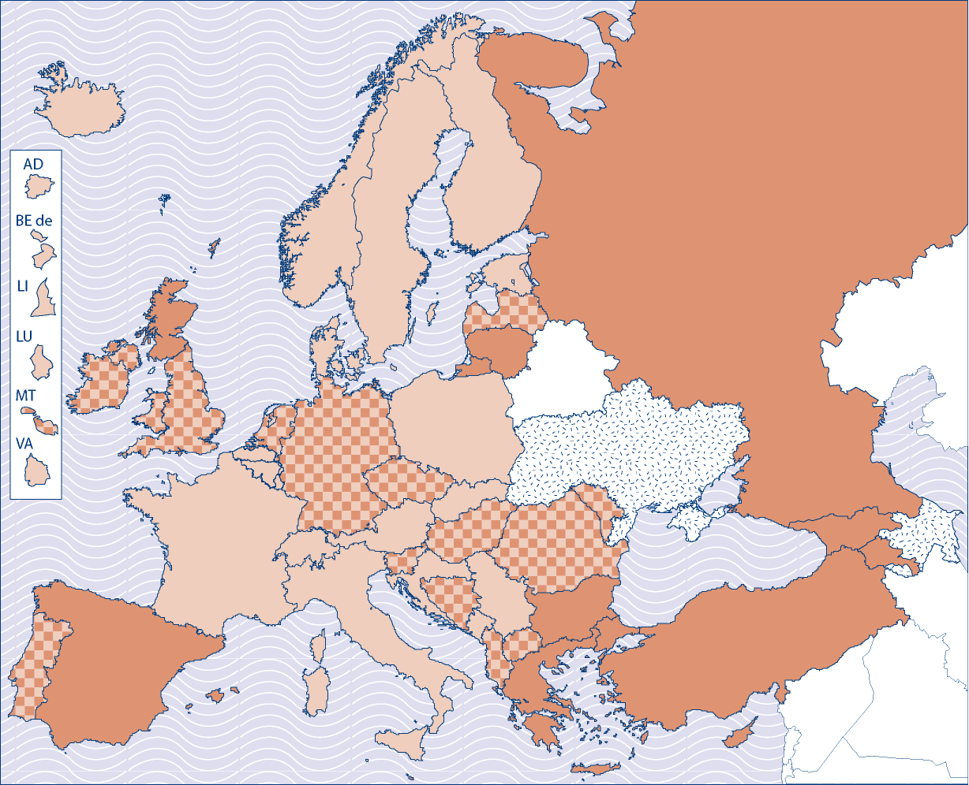
 | 240 ECTS credits (4 academic years) |  | 180 ECTS credits (3 academic years) |  | Not available
Source: Eurydice.
Explanatory note
Countries have adapted the Bologna principles to their own situation and may have implemented them in a flexible way to take into account specificities of the labour market, of institutions and study fields or disciplines. Therefore, a unique model has not necessarily been designed and applied in each country, and institutions may have been given space to adapt. Nevertheless, in most countries a common approach or 'reference model' stands out in practice. This figure tries to capture this situation.

No modifications
Data for 2009/2010 have changed with respect to the 2009 edition.
If this is the case, please enter the new data in the table below using the following key
1. Legislation to introduce or adapt the Bologna three cycle system has been adopted in 2009
2. Significant steps to introduce or adapt the Bologna three cycle system have been taken since 2008
Current reforms: Indicate their content and planned date of application: Please give details and web addresses for further information
Comments:
1.2 Figure A2: Student workload/duration for the most common Master programmes, 2008/09
Extract from Higher Education 2009, P19

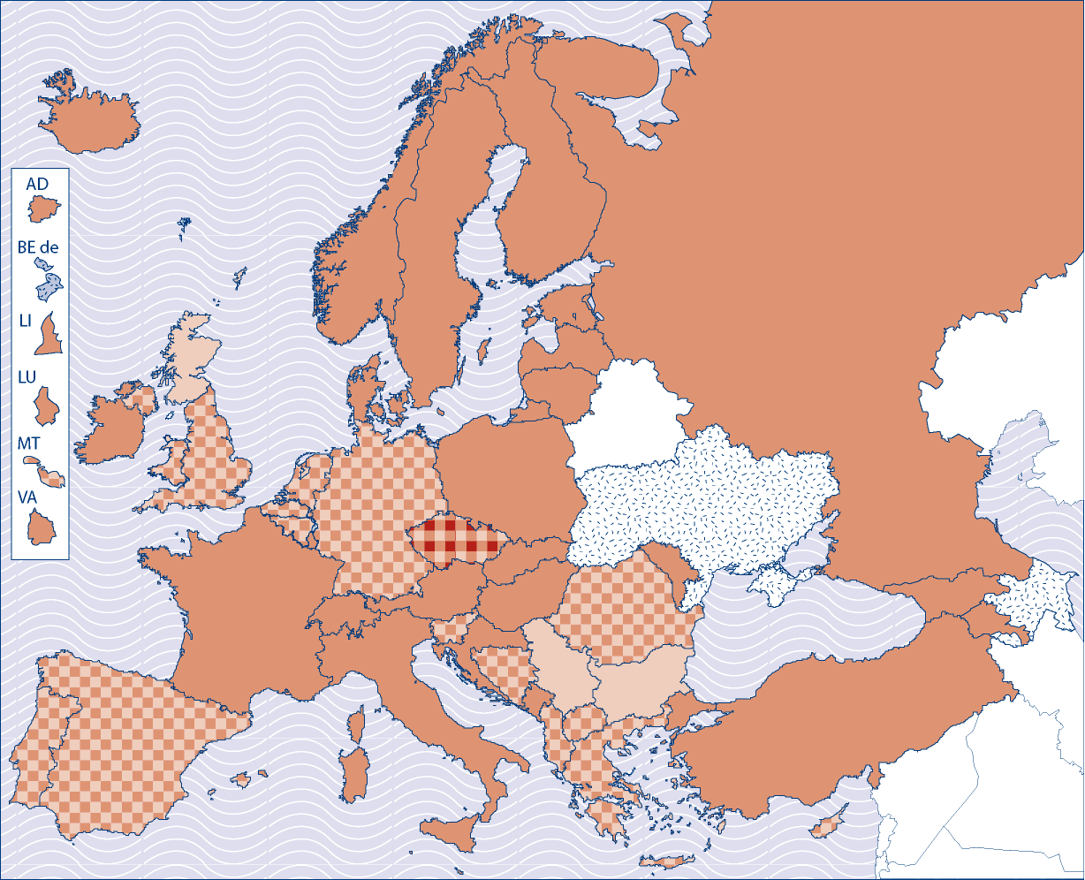

 | 180 ECTS credits (3 academic years) |  | 120 ECTS credits (2 academic years) |  | 60 ECTS credits (1 academic year)
 | No Master programmes |  | Not available
Source: Eurydice.
Explanatory note
Countries have adapted the Bologna principles to their own situation and may have implemented them in a flexible way to take into account specificities of the labour market, of institutions and study fields or disciplines. Therefore, a unique model has not necessarily been designed and applied in each country, and institutions may have been given space to adapt. Nevertheless, in most countries a common approach or 'reference model' stands out in practice. This figure tries to capture this situation

No modifications
Data for 2009/2010 have changed with respect to the 2009 edition.
If this is the case, please enter the new data in the table below using the following key
1. Legislation to introduce the Bologna three cycle system has been adopted in 2009
2. Significant steps to introduce the Bologna three cycle system have been taken since 2008
Current reforms: Indicate their content and planned date of application: Please give details and web addresses for further information
Comments:

1.3 Figure A3: Two-cycle structure models most commonly implemented, 2008/09
Extract from Higher Education 2009, P20

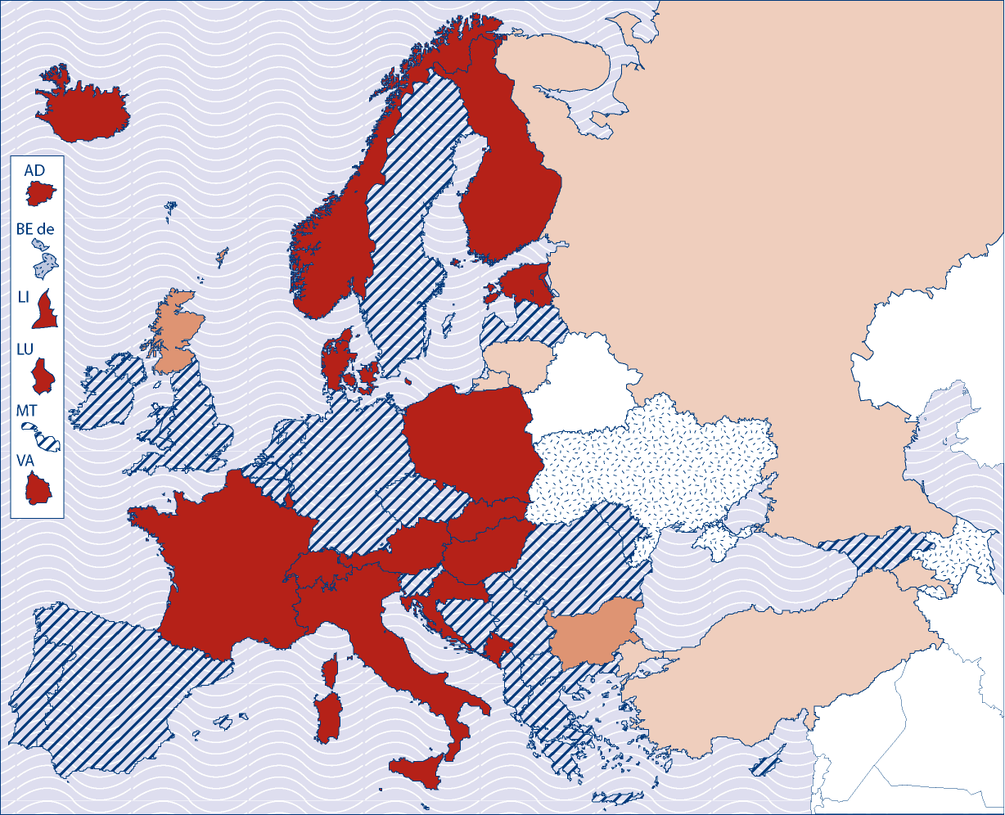

 | 240 + 120 credits  (4+2 academic years) model |  | 240 + 60 credits  (4+1 academic years) model |  | 180 + 120 credits  (3+2 academic years) model
 | Various combinations |  | No Master programmes |  | Not available
Source: Eurydice.
Explanatory note
Countries have adapted the Bologna principles to their own situation and may have implemented them in a flexible way to take into account specificities of the labour market, of institutions and study fields or disciplines. Therefore, a unique model has not necessarily been designed and applied in each country, and institutions may have been given space to adapt. Nevertheless, in most countries a common approach or 'reference model' stands out in practice. This figure tries to capture this situation.

No modifications
Data for 2009/2010 have changed with respect to the 2009 edition.
If this is the case, please enter the new data in the table below using the following key
1. Legislation to introduce the Bologna three cycle system has been adopted in 2009
2. Significant steps to introduce the Bologna three cycle system have been taken since 2008
Current reforms: Indicate their content and planned date of application: Please give details and web addresses for further information
Comments:
1.4 Figure A4: Application of the Bologna structure to ISCED 5B level programmes,2008/09
Extract from Higher Education 2009, P22

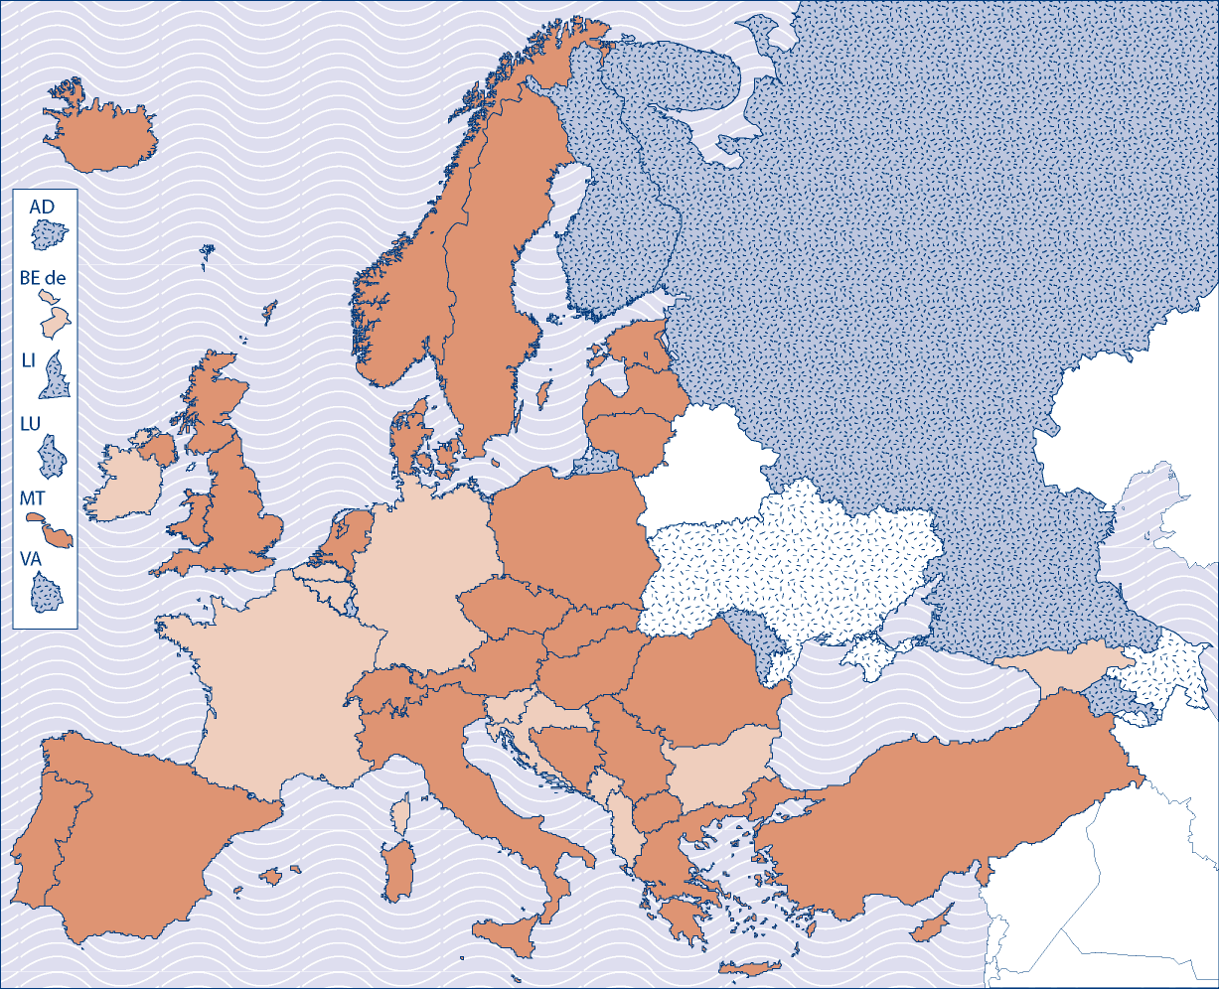

 | ISCED 5B provision not changed as a part of Bologna reforms |  | ISCED 5B provision integrated within Bologna reforms |  | No ISCED 5B level provision |  | Not available
Source: Eurydice.
Explanatory note
ISCED 5B level corresponds to programmes with a clear vocational orientation that are typically shorter than ISCED 5A programmes. They do not necessarily conform to the Bologna structure/principles but some countries have nevertheless taken this opportunity to revise their programmes to ensure links and flexibility between vocational and academic programmes. In particular, the Bachelor concept may have been adapted/applied to ISCED 5B level programmes.

No modifications
Data for 2009/2010 have changed with respect to the 2009 edition.
If this is the case, please enter the new data in the table below using the following key
1. Legislation to apply the Bologna three cycle system to ISCED 5B has been adopted in 2009
2. Significant steps to include ISCED 5B into the Bologna three cycle system have been taken since 2008
Current reforms: Indicate their content and planned date of application: Please give details and web addresses for further information
Comments:

The Bologna tools
1.5 Figure B1: Legislation concerning ECTS, 2008/09
Extract from Higher Education 2009, P27

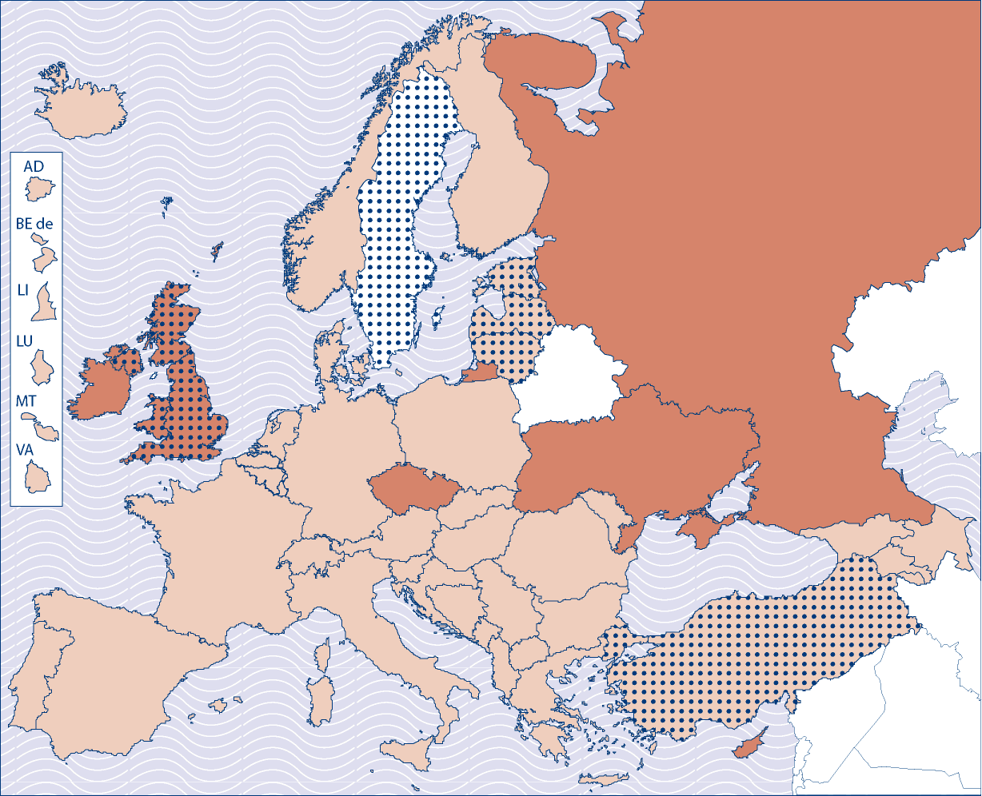

 | Legislation governing the arrangements for implementing ECTS |  | ECTS being introduced without legislation
 | National credit systems parallel or compatible with ECTS |  | Not available
Source: Eurydice.

No modifications
Data for 2009/2010 have changed with respect to the 2009 edition.
If this is the case, please enter the new data in the table below using the following key
1. Legislation to introduce the ECTS system has been adopted in 2009
2. The ECTS system has been introduced without legislation since 2008
Please indicate the sources of data used for modifications
Comments:

1.6 Figure B2: Level of implementation of ECTS, 2008/09
Extract from Higher Education 2009, P29

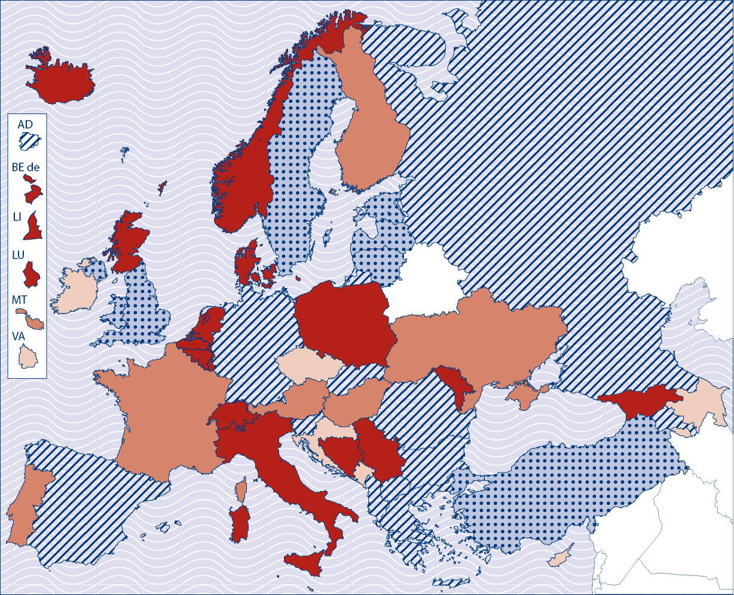

More than 75 % of institutions and programmes are using ECTS for both transfer and accumulation purposes. Allocation of ECTS is based on learning outcomes and student workload.
More than 75 % of institutions and programmes are using ECTS for both transfer and accumulation purposes. Allocation of ECTS is based on student workload.
More than 75 % of institutions and programmes are using ECTS for both transfer and accumulation purposes. Allocation of ECTS is based on contact hours, or a combination of contact hours and student workload.
75 % or less institutions and/or 75 % or less programmes are using ECTS for both transfer and accumulation purposes. Various references are used to define the credits.
National credit systems parallel or compatible with ECTS. ECTS is mainly used for transfer purposes.
Source: Eurydice.
No modifications
Data for 2009/2010 have changed with respect to the 2009 edition. | (If this is the case, please enter the new data in the table below using the following key)
Key:
1 Since 2009 more than 75 % of institutions and programmes are using ECTS for both transfer and accumulation purposes. Allocation of ECTS is based on learning outcomes and student workload
2. Since 2009 more than 75 % of institutions and programmes are using ECTS for both transfer and accumulation purposes. Allocation of ECTS is based on student workload.
3. Since 2009 More than 75 % of institutions and programmes are using ECTS for both transfer and accumulation purposes. Allocation of ECTS is based on contact hours, or a combination of contact hours and student workload.
4. Since 2009 75 % or less institutions and/or 75 % or less programmes are using ECTS for both transfer and accumulation purposes. Various references are used to define the credits.
Please indicate the sources of data used for modifications
Comments:

1.7 Figure C1: Level of implementation of the Diploma Supplement, 2008/09
Extract from Higher Education 2009, P32

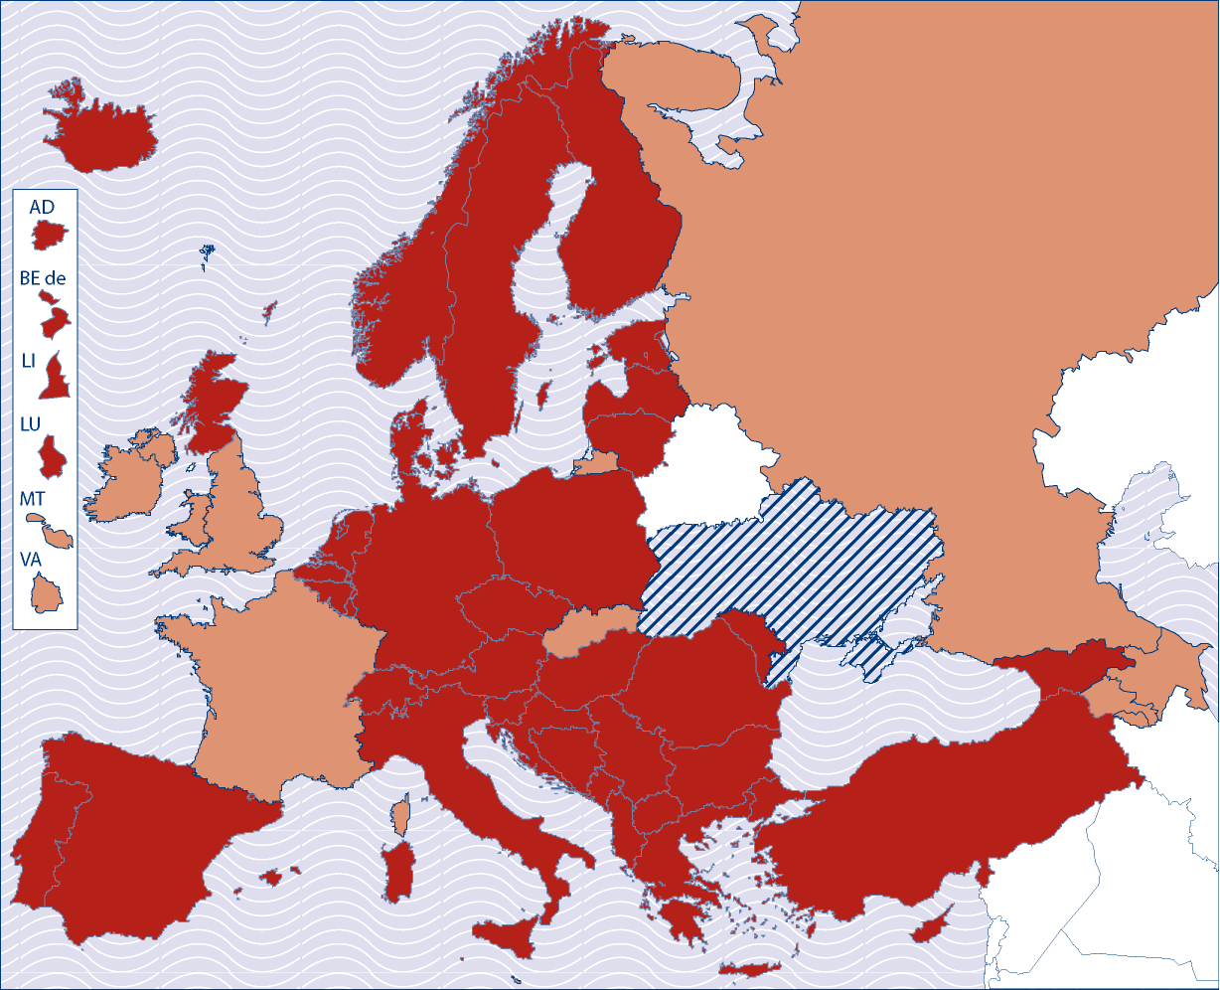
 | DS issued in vast majority of study programmes |  | Partial and gradual introduction |  | DS not yet introduced
Source: Eurydice.

No modifications
Data for 2009/2010 have changed with respect to the 2009 edition. | (If this is the case, please enter the new data in the table below using the following key)
Key:
1 Since 2009 the DS is issued in the vast majority of study programmes
2. The introduction of DS has been begun, but is still partial.
Please indicate the sources of data used for modifications
Comments:
1.8 Figure C2: National monitoring of the usage of the Diploma Supplement, 2008/09
Extract from Higher Education 2009, P33

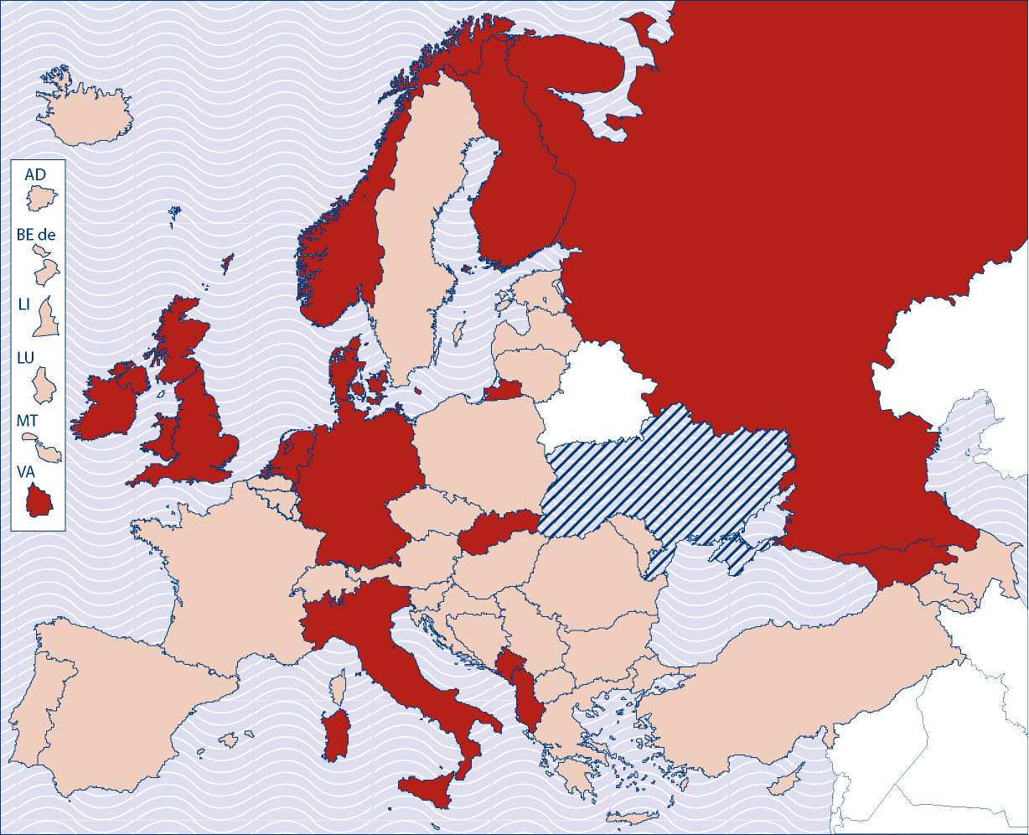

 | National monitoring has been undertaken or is planned |  | No national monitoring |  | DS not introduced
Source: Eurydice.
Explanatory note
The figure indicates if any national monitoring has been undertaken to find out how the Diploma Supplement is used by employers and/or higher education institutions.

No modifications
Data for 2009/2010 have changed with respect to the 2009 edition. | (If this is the case, please enter the new data in the table below using the following key)
Key:
1 Since 2009 the issuing of the DS is monitored.
2. Since 2009 the monitoring of the DS has been planned.
Current reforms: Indicate their content and planned date of application: Please give details and web addresses for further information
Comments:

1.9 Figure C3: Compliance with the conditions that the Diploma Supplement be issued automatically and free of charge, 2008/09
Extract from Higher Education 2009, P36

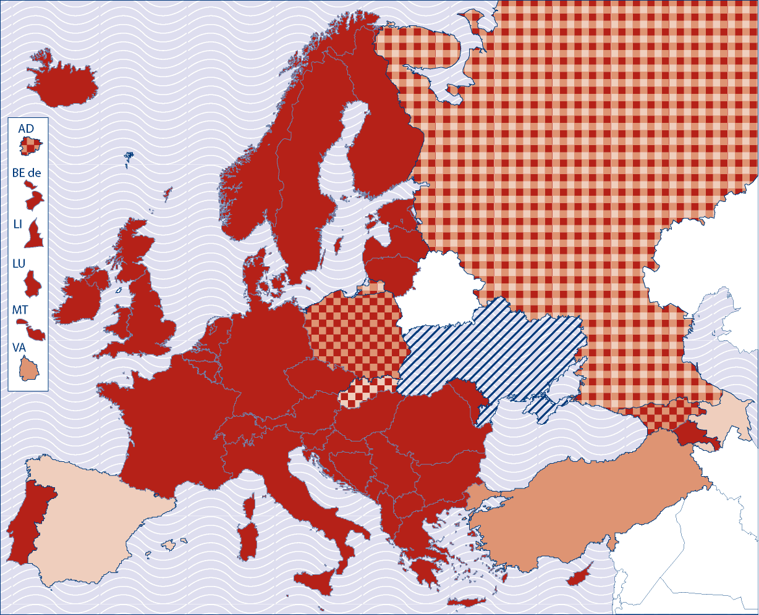

 | Automatically and  free of charge |  | On request and  free of charge |  | On request and  in return of payment |  | DS not yet  introduced
Source: Eurydice.

No modifications
Data for 2009/2010 have changed with respect to the 2009 edition. | (If this is the case, please enter the new data in the table below using the following key)
Key:
1 Since 2009 the DS is issued automatically and free of charge to all graduating students.
2. Since 2009 the DS is issued on request and free of charge to all graduating students.
3. Since 2009 the DS is issued on request and in return of payment to all graduating students.
Please indicate the sources of data used for modifications
Comments:

1.10 Figure C4: Languages in which the Diploma Supplement is issued, 2008/09
Extract from Higher Education 2009, P37

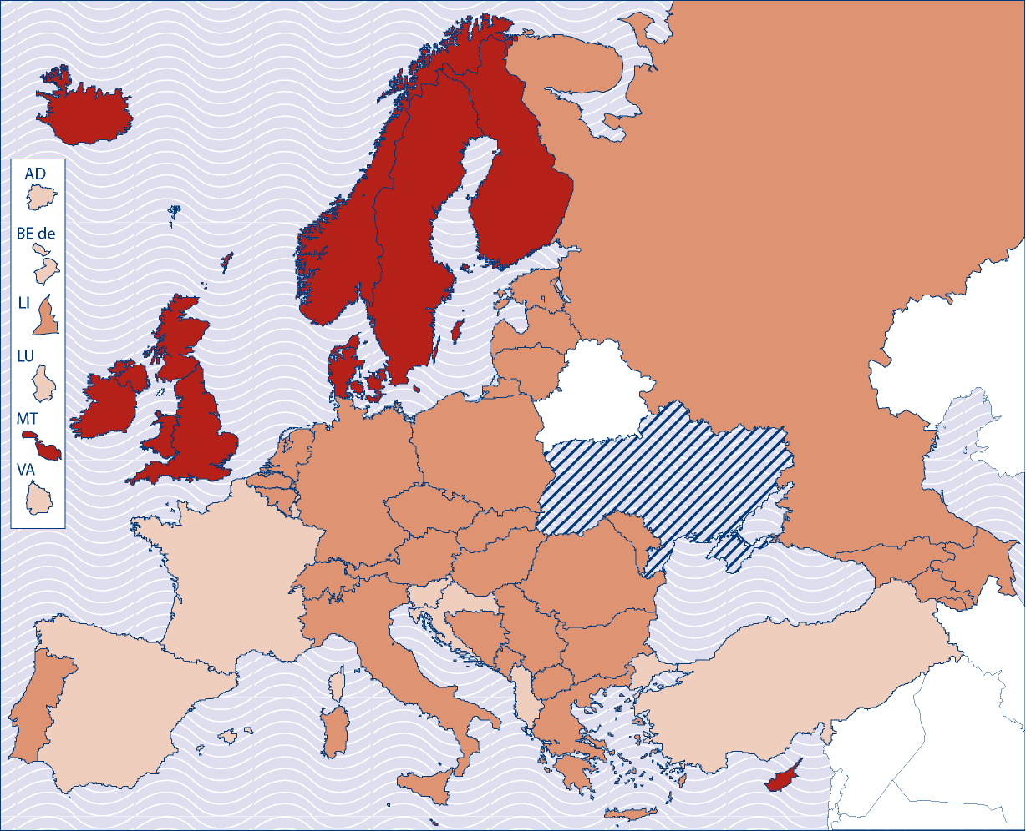

 | Solely  in English |  | In the language of instruction  and/or English |  | In the language of instruction  and/or more official EU languages |  | DS not yet  introduced

Source: Eurydice.

No modifications
Data for 2009/2010 have changed with respect to the 2009 edition. | (If this is the case, please enter the new data in the table below using the following key)
Key:
1 Since 2009 the DS is issued solely in English.
2. Since 2009 the DS is issued in the language of instruction and/or English.
3. Since 2009 the DS is issued in the language of instruction and/or more official EU languages.
Current reforms: Indicate their content and planned date of application: Please give details and web addresses for further information
Comments:

1.11 Figure D2: Stage towards establishing a National Qualification Framework, 2008/09
Extract from Higher Education 2009, P41

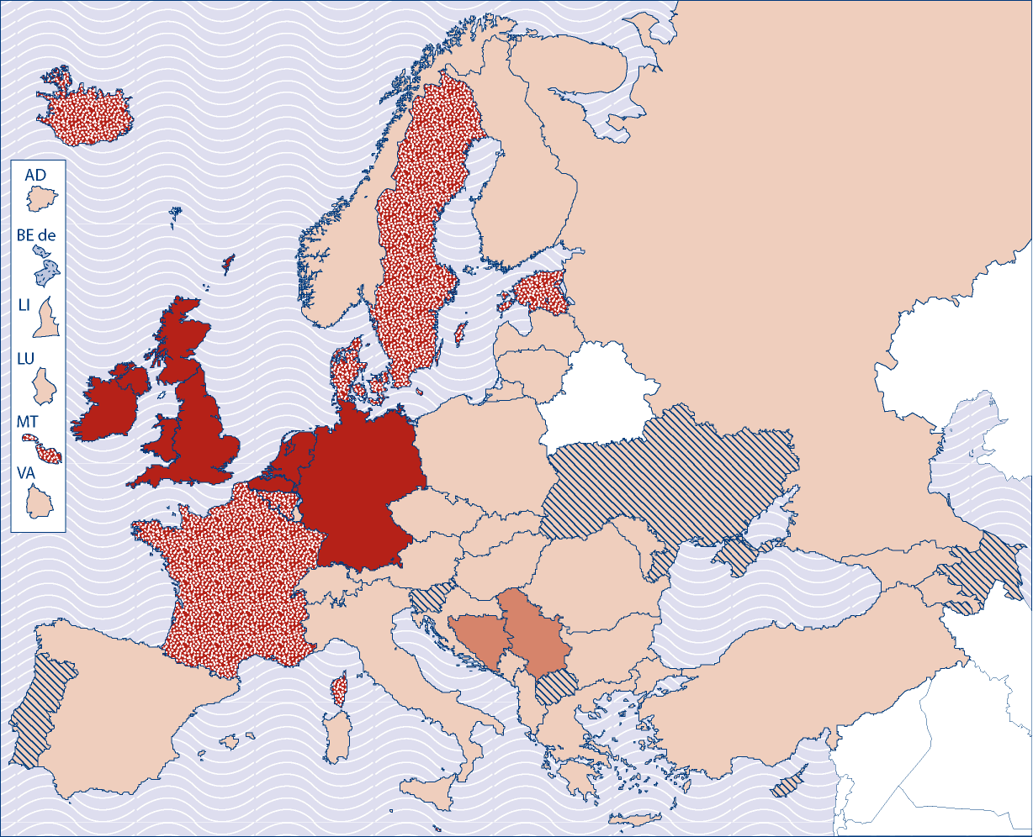

Step 5: Overall process fully completed including self-certified compatibility with the FQ-EHEA.
Step 4: Redesigning the study programmes is on-going and the process is close to completion.
Step 3: The NQF has been adopted formally and the implementation has started.
Step 2: The purpose of the NQF has been agreed and the process is under way including discussions and consultations. Various committees have been established.
Step 1: Decision taken. Process just started.
Not yet started formally.
Source: Eurydice.
No modifications
Data for 2009/2010 have changed with respect to the 2009 edition.
If this is the case, please enter the new data in the table below using the following key
1 Since 2009 a fully completed NQF which is compatible with the FQ-EHEA exists
2. Since 2009 the study programmes are being redesigned and the process is close to completion.
3. Since 2009 a NQF has been adopted and the implementation has started.
4. Since 2009 the purpose of the NQF has been agreed and the process is under way. Various committees have been established.
5. Decision to establish a NQF has been taken in 2009. Process has just started.
Current reforms: Indicate their content and planned date of application: Please give details and web addresses for further information
Comments:

1.12 Figure E2: Full-time national student contributions to the costs of higher education, 2008/09
Extract from Higher Education 2009, P41

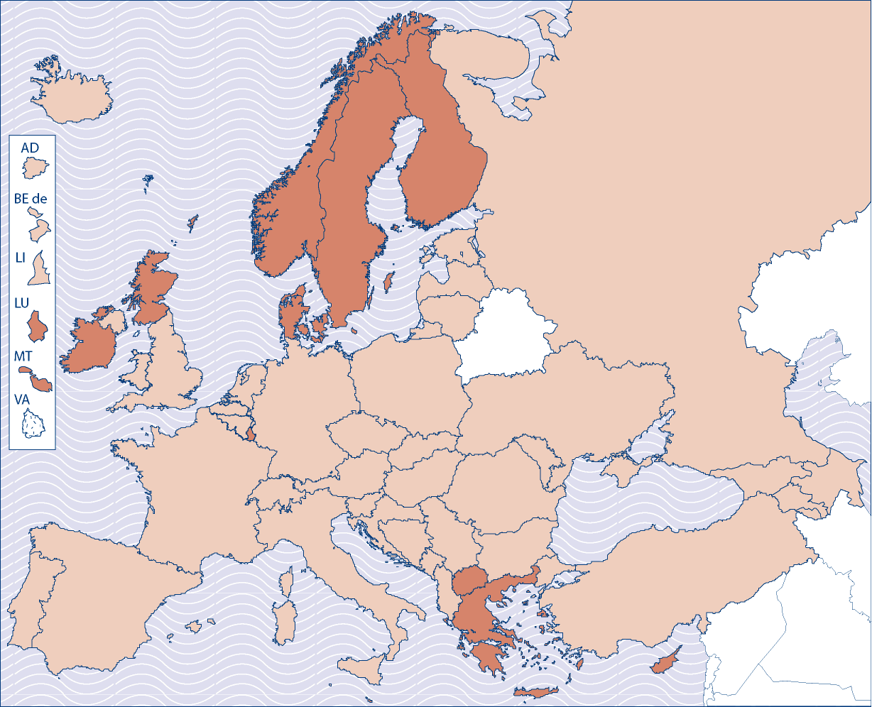

 | Some or all students contribute to costs |  | No students contribute to costs |  | Data not available
Source: Eurydice.
Explanatory note
This map shows the countries in the European Higher Education Area where some or all full-time national students are required to contribute to costs of higher education. For students from another European Union member country studying within the EU the same conditions apply as for national students. The map makes no distinction between costs charged to students as administrative fees or as tuition fees. Contributions to student organisations are also ignored.

Source: Eurydice.

No modifications
Data for 2009/2010 have changed with respect to the 2009 edition.
If this is the case, please enter the new data in the table below using the following key
1 Since 2009 some or all students contribute to costs
2. Since 2009 no students contribute to cost.
Current reforms: Indicate their content and planned date of application: Please give details and web addresses for further information
Comments:

Part 2 Data on national Higher Education Systems (For National Diagrams)
2.1 Which officially recognised types of institutions offer programmes leading to a higher education degree?
Please provide the original name and the English translation.
 |  |  |  | 1st cycle |  |  | 2nd cycle |  |  |  | 3rd cycle |  |  |  | Higher education programmes not compatible with Bologna cycles
ISCED 5B
ISCED 5A
ISCED 6
Generic names of degrees provided by these institutions
Number of institutions in each column
2.2 Please look at the national diagram for your country in the report, Focus on the Structures of Higher Education in Europe 2006/7, and indicate any changes to be taken into account in updating the diagram

Data on the first cycle
2.3 What is the most common age for students to begin their first cycle programme?

2.4 Please provide the following information on the length of first cycle (bachelor) study programmes.
ECTS |  |  |  |  | 180 |  |  |  |  | 240 |  |  | Other (please specify) |  |  |  | Total
Percentage of first cycle (Bologna) study programmes |  |  |  |  |  |  |  |  |  |  |  |  |  |  |  |  | = 100%
Percentage of the total number of first cycle students enrolled in these programmes |  |  |  |  |  |  |  |  |  |  |  |  |  |  |  |  | = 100%
2.5 Do first cycle study programmes exist at ISCED 5A level that are not compatible with the Bologna structure (ie 180 – 240 ECTS)? (please tick one box)
Yes Please provide details of the length of these programmes and the study fields concerned:
No
2.6 If first cycle programmes exist at ISCED 5B level that are not compatible with the Bologna structure (ie 180 - 240 ECTS), please provide the following information.
What is the typical length of these first cycle programmes?
What percentage of first cycle students are enrolled in these programmes?
2.7 Do all first cycle qualifications give direct access to at least one second cycle (master) study programme? (please tick one box)
Yes
No |  |  | Please specify:
2.8 Do any first cycle qualifications give direct access to the third cycle (PhD)? (please tick one box)
Yes |  |  | If Yes, please tick if any of these programmes are within the Bologna structure |  |  |  |  | Details and conditions
 |  |  | If Yes, please tick if any of these programmes are outside the Bologna structure |  |  |  |  | Details and conditions
No
Data on the second cycle

2.9 Please provide the following information on the length of second cycle (master) study programmes.
ECTS |  |  |  | 60 - 75 |  | 90 |  |  | 120 |  |  | Other (please specify) |  |  |  | Total
Percentage of second cycle (master) study programmes |  |  |  |  |  |  |  |  |  |  |  |  |  |  |  | = 100%
Percentage of the total number of second cycle students enrolled in these programmes |  |  |  |  |  |  |  |  |  |  |  |  |  |  |  | = 100%
2.10 Do other second cycle programmes exist that are not compatible with the Bologna structure (ie 60 – 120 ECTS)? (please tick one box)

Yes |  |  |  |  |  |  | Please provide details of the length of these programmes and the study fields concerned:
No
2.11 Do all second cycle (master) qualifications give direct access to third cycle (Phd) studies? (please tick one box)
Yes
No |  |  |  |  |  |  | Please provide details:
Data on the third cycle
2.12 What is the most typical length (in years) of full-time third cycle (PhD) study programmes?

Part 3 Developments in higher education over the Bologna period
3.1 What was the total number of students enrolled in higher education institutions for the following reference years?

 |  |  |  |  | Total
1999/2000
2008/2009
Please indicate the source of the data
3.2 What was the total number of recognised higher education institutions operating in your country in the following reference years?
1999/2000
2008/2009 |  |  |  |  |  |  | Please indicate the source of the data:
3.3 For the year 2008/9, please indicate the percentage of higher education institutions offering the following levels of programmes:
ISCED 5B: First cycle and short cycle |  | 0 – 10% |  |  |  | 11 – 30% |  | 31 – 50% |  |  |  |  | 51 – 70% |  |  |  | 71 – 90% |  |  |  | 91 – 100%
ISCED 5B: Second cycle |  | 0 – 10% |  |  |  | 11 – 30  % |  | 31 – 50% |  |  |  |  | 51 – 70% |  |  |  | 71 – 90% |  |  |  | 91 – 100%
ISCED 5A: First cycle |  | 0 – 10% |  |  |  | 11 – 30  % |  | 31 – 50% |  |  |  |  | 51 – 70% |  |  |  | 71 – 90% |  |  |  | 91 – 100%
ISCED 5A: Second cycle |  | 0 – 10% |  |  |  | 11 – 30  % |  | 31 – 50% |  |  |  |  | 51 – 70% |  |  |  | 71 – 90% |  |  |  | 91 – 100%
ISCED 6: third cycle |  | 0 – 10% |  |  |  | 11 – 30  % |  | 31 – 50% |  |  |  |  | 51 – 70% |  |  |  | 71 – 90% |  |  |  | 91 – 100%
3.4 For the majority of institutions and programmes, did a three cycle degree system like the one introduced by the Bologna process already exist in 1999/2000? (please tick one box)

Yes
No
3.5 In 1999/2000 what percentage of higher education institutions and programmes in your country were using the ECTS system?
 |  |  |  |  |  |  |  |  |  |  | 0-25% |  |  | 25 – 50% |  | 50 – 75% |  |  | 75 – 100%
Higher Education Institutions using ECTS for both credit accumulation and transfer
Higher Education Institutions using ECTS for credit transfer only
Programmes using ECTS for credit accumulation and transfer
Programmes using ECTS for transfer only
3.6 In 2008/2009 what percentage of higher education institutions and programmes in your country were using the ECTS system?
 |  |  |  |  |  |  |  |  |  | 0-25% |  |  |  | 25 – 50% | 50 – 75% |  |  |  |  | 75 – 100%
Higher Education Institutions using ECTS for both credit accumulation and transfer
Higher Education Institutions using ECTS for credit transfer only
Programmes using ECTS for credit accumulation and transfer
Programmes using ECTS for transfer only
3.7
a) If legislation has been adopted to introduce the Diploma Supplement, in what year did this take place?
b) In what year was the Diploma Supplement first issued to some graduates in your country?
c) If the Diploma Supplement is now issued to all graduates in your country, in what year was the Diploma Supplement first issued to all graduates?
3.8 Please give an indication of the three most important national priorities of higher education policy in 1999, and today
1999/2000 |  |  | 1 |  |  |  |  |  | 2 |  |  |  |  |  |  |  | 3
2009/2010 |  |  | 1 |  |  |  |  |  | 2 |  |  |  |  |  |  |  | 3

Part 4 Impact of the economic crisis on higher education
Immediate impact of the economic crisis and current policy strategies in the higher education sector
4.1 At national level, has the current economic crisis had any immediate effects on higher education? (please tick one box)
Yes |  |  | Please specify, including information on matters such as funding of institutions and/or students, student enrolments etc
No
4.2 Has the government already taken specific policy measures that affect higher education? (please tick one box)
Yes |  |  | If yes, please provide details.
No
4.4 What plans, if any, are in place to monitor the impact of these measures?
Changes in public funding.

4.5 Please indicate how public spending on higher education is changing
 |  |  |  |  |  |  |  |  |  |  |  | Budget for reference academic year 2009/10 compared to 2008/9
Increase of public spending on higher education |  |  |  |  |  |  |  |  |  |  |  | 0 - 3%
 |  |  |  |  |  |  |  |  |  |  |  | 3.1 - 5%
 |  |  |  |  |  |  |  |  |  |  |  | 5.1 - 8%
 |  |  |  |  |  |  |  |  |  |  |  | 8.1 - 10%
 |  |  |  |  |  |  |  |  |  |  |  | More than 10%
Same level of spending on higher education

Decrease in spending on higher education |  |  |  |  |  |  |  |  |  |  |  | 0 - 3%
 |  |  |  |  |  |  |  |  |  |  |  | 3.1 - 5%
 |  |  |  |  |  |  |  |  |  |  |  | 5.1 - 8%
 |  |  |  |  |  |  |  |  |  |  |  | 8.1 - + 10%
 |  |  |  |  |  |  |  |  |  |  |  | 10% - 20%
 |  |  |  |  |  |  |  |  |  |  |  | More than 20%
4.6 Have any priorities of higher education policy changed (in response to the crisis) for the academic year 2009/10 in relation to 2008/9? (please note your answer to Q 3.7)

Yes
No
If Yes, please explain which areas of higher education policy are to be prioritised, and which former priorities have been sacrificed.
Changes in regulatory frameworks.
4.7 Has your government enacted changes in the higher education regulatory framework (laws, regulations, administrative orders) since September 2008, that may be linked to the crisis?

Yes |  |  |  | Please explain the nature of these measures, the rationale for their introduction, and provide a reference to the relevant legislation
 |  |  |  | Nature of measures |  |  |  |  | Rationale for new measures |  |  |  | Reference to legislation (including electronic reference)
No

Part 5 Lifelong learning
Lifelong learning in higher education policy
5.1 Is lifelong learning a recognised mission of higher education institutions?

Yes, of all institutions |  |  |  |  |  |  |  |  |  | Please explain the concept and understanding of lifelong learning, giving examples of activities and services that are included:
Yes, of some institutions |  |  |  |  |  |  |  |  |  | Please explain the concept and understanding of lifelong learning, which institutions are and are not concerned, and giving examples of activities and services that are included:
No |  |  |  |  |  |  |  |  |  | Please go to Q 5.8
5.2 Are there any legal requirements for higher education institutions to offer lifelong learning services? (please tick one box)
Yes |  |  |  |  |  |  |  |  | Since when: |  |  |  |  |  |  | What services are higher education institutions required to offer?
No
5.3 Have any incentives have been put in place to stimulate higher education institutions to improve and develop lifelong learning services? (please tick one box)

Yes |  |  |  |  | Please give further information or indicate where further information can be found:
No
5.4 Is a part of the budget for the academic year 2009/2010 earmarked specifically for spending on lifelong learning?
Yes |  |  |  |  | What is the percentage of the total higher education budget for specific LLL activity? |  |  |  |  |  |  |  |  |  |  |  |  |  |  | 0.1-2.5 %
Yes |  |  |  |  |  |  |  |  |  |  |  |  |  |  |  |  |  |  |  | 2.6 – 5.0 %
Yes |  |  |  |  |  |  |  |  |  |  |  |  |  |  |  |  |  |  |  | 5.1-10.0 %
Yes |  |  |  |  |  |  |  |  |  |  |  |  |  |  |  |  |  |  |  | 10.1 - 15%
Yes |  |  |  |  |  |  |  |  |  |  |  |  |  |  |  |  |  |  |  | 15.1 – 30 %
Yes |  |  |  |  |  |  |  |  |  |  |  |  |  |  |  |  |  |  |  | 30.1 – 50%
Yes |  |  |  |  |  |  |  |  |  |  |  |  |  |  |  |  |  |  |  | 50.1 – 75%
Yes |  |  |  |  |  |  |  |  |  |  |  |  |  |  |  |  |  |  |  | 75.1 + 100%
No |  |  |  |  | How are policy measures regarding LLL funded?
5.5 Does your higher education policy take specific measures and/or provide incentives to encourage the participation of the following types of student?
 |  |  |  |  |  |  |  |  |  |  |  |  |  |  | If yes, please give details:
… part-time students? |  |  |  |  |  |  |  |  |  |  | Yes
 |  |  |  |  |  |  |  |  |  |  | No
Please define "part-time student' in your higher education system, with reference to such concepts as number of credits, hours of study, age of students etc :
… adults in employment? |  |  |  |  |  |  |  |  |  |  | Yes
 |  |  |  |  |  |  |  |  |  |  | No
… unemployed adults? |  |  |  |  |  |  |  |  |  |  | Yes
 |  |  |  |  |  |  |  |  |  |  | No
… retired adults? |  |  |  |  |  |  |  |  |  |  | Yes
 |  |  |  |  |  |  |  |  |  |  | No
… others: Please specify |  |  |  |  |  |  |  |  |  |  | Yes
 |  |  |  |  |  |  |  |  |  |  | No
Comment:
5.6 In 2009/10 have any national and/or regional information and/or awareness-raising campaigns been organised or planned to inform the general public about opportunities for lifelong learning in higher education?

Yes |  |  |  |  |  |  |  | Please indicate where further information can be found
No
5.7 Have there been any recent government measures to stimulate cooperation on lifelong learning provision between higher education institutions and the private sector (business/industry)?

Yes |  |  |  |  |  | Please give further information about the rationale for these measures and/ or indicate where further information can be found.
No
RECOGNITION OF PRIOR LEARNING
5.8 If it exists, please provide a reference to legislation that regulates recognition of prior learning.
5.9 How does this legislation (or any other relevant measure) define prior learning?

5.10 Can prior learning as defined by legislation and/or policy … (please tick one box)

….be used to gain admission to a higher education study programme?
… be taken into account as partial fulfilment of a higher education study programme (e.g. to reduce the required amount of courses to be taken/credits to be gained)?
… Other (please specify):
5.11 Based on your definition of prior learning, can applicants for higher education have their learning assessed and recognised? (please tick one box)

Yes, this is a legal right |  |  |  |  |  |  |  |  |  |  |  |  |  |  |  |  |  |  |  |  | Please go to Q 5.13
Yes, this is permitted by legislation, although it is not a right |  |  |  |  |  |  |  |  |  |  |  |  |  |  |  |  |  |  |  |  | Please go to Q 5.12
No, this kind of procedure cannot happen in higher education in this country |  |  |  |  |  |  |  |  |  |  |  |  |  |  |  |  |  |  |  |  | Please go to Part 6
5.12 If recognition of prior learning is permitted by legislation but is not a right, is it:
Standard practice in most higher education institutions (75% +)
Standard practice in some higher education institutions (35 - 75%)
Standard practice in few higher education institutions (5 - 35%)
Very unusual practice in higher education institutions (less than 5%)
5.13 If recognition of prior learning is practised, what measures are in place to ensure that assessment of learning is based on reliable and valid evidence?
5.14 Is there a legal requirement for prior learning decisions to be subject to appeal and review?
Yes
No
5.15 Is institutional practice in recognition of prior learning explicitly included in the quality assurance processes used to evaluate institutions and/or programmes?

Yes
No

Part 6 THE SOCIAL DIMENSION OF HIGHER EDUCATION
This section focuses on national action to meet the Ministerial commitment expressed in the London Communiqué that "the student body entering, participating in and completing higher education at all levels should reflect the diversity of our populations". Following the work undertaken on the Social Dimension of higher education within the Bologna Follow Up Group, this section picks up the recommendation of the Bologna working group that "each country should develop its own strategy, including an action plan, for the social dimension. Initially such a strategy will call for the identification of possible under-represented groups." The questions therefore focus on issues regarding possible under-represented groups in higher education.
6.1 Is the (under-) participation in higher education of particular societal groups monitored in your country?

Yes
No
If you answered no, please DO NOT ANSWER the rest of the questions in this part of the questionnaire and go to Part 7
6.2 If you answered 'yes', please explain how you define these groups in policy, legal and/or administrative documents.
(e.g. on the basis of socio-economic status, gender, ethnicity, language, disability, geography etc…)
Main categories of societal groups |  |  |  |  | 1
 |  |  |  |  | 2
 |  |  |  |  | 3
 |  |  |  |  | 4
 |  |  |  |  | More/other
6.3 How do you determine whether a person belongs to one of those groups?
e.g. self-declaration in census data, administrative decision based on tax revenue/nationality etc

6.4 What main reasons have been identified in your higher education policy to explain the underrepresentation of these groups in higher education?
Reason(s) linked to group 1
Reason(s) linked to group 2
Reason(s) linked to group 3
Reason(s) linked to group 4
Reasons linked to other groups
6.5 Does your national policy set targets or benchmarks for the participation of underrepresented groups in higher education?
Yes |  |  |  | Please specify these targets/benchmarks for each relevant group
No
6.6 Have you developed specific action to stimulate participation of underrepresented societal groups in higher education?

Yes |  |  |  | If yes, please describe the main characteristics of this policy/strategy for each group:
No |  |  |  |  |  | Group |  | Measures targeted at that group
6.7 Are there any financial or other incentives for higher education institutions to increase the participation of members of under-represented groups?
Yes |  |  |  | Please specify these incentives, and give details of where further information may be found
No
6.8 Are any of the following measures targeted specifically to members of under-represented groups?
Information campaigns |  |  |  |  |  |  |  |  |  |  |  | Comment
Outreach programmes in the community |  |  |  |  |  |  |  |  |  |  |  | Comment
Academic guidance services |  |  |  |  |  |  |  |  |  |  |  | Comment
Special procedures for admission to higher education |  |  |  |  |  |  |  |  |  |  |  | Comment
Scholarships and grants |  |  |  |  |  |  |  |  |  |  |  | Comment
Other |  |  |  |  |  |  |  |  |  |  |  | Please specify:
6.9 Do you monitor the effect of your policies to address underrepresentation?

Yes |  |  |  | Which institutions are involved in this monitoring process, and where can the results of such monitoring be found?
No
6.11 Do you systematically/ routinely collect data on the number of students of each group and their completion rates?
Yes |  |  |  | Please specify where this data can be found
No

Part 7 Policies on fostering student mobility in the EHEA
Student mobility is a core element of the European Higher Education Area, and key to enhancing attractiveness of European higher education. The Bologna ministers have adopted a benchmark according to which 20 percent of students ought, by 2020, to have experienced a period of mobility during their higher education studies.
The following questions therefore aim to improve understanding of national policy and practice with regard to student mobility.

OUTBOUND MOBILITY
7.1 Do you have explicit policies to promote the outbound mobility of national students during their higher education studies?

Yes |  |  | Please provide a reference to the main documents related to these policy measures
No |  |  | Please DO NOT ANSWER questions 2-5
7.2 Are these policies targeted at all students, or at a part of the student body?
All
Part |  |  | Which students are concerned?  (eg, criteria may be related to cycle of studies, subject area, socio-economic status etc)
7.3 What are the main measures that you undertake within this policy?

7.4 How are the effects of these measures monitored?
7.5 Does your national higher education policy contain benchmarks or targets for the outbound mobility of students?

Yes |  |  | What are they?
No
7.6 Does your national data provide information on
 |  |  |  |  |  |  |  |  |  |  | If yes, which organisation/institution collects the data | If yes, where can the data be found
Students who study abroad as part of the first cycle (exchange students)
Students who study abroad for a first cycle qualification
Students who study abroad as part of the second cycle (exchange students)
Students who study abroad for a second cycle qualification
Students who study abroad as part of the third cycle
INBOUND MOBILITY
7.7 Do you have explicit national policies to promote higher education study opportunities to students from other countries?

Yes |  |  |  | Please provide a reference to the main documents related to these policy measures
No |  |  |  | Please DO NOT ANSWER questions 2-4
7.8 Which of the following regions is a priority for attracting students?

 |  |  |  |  | EU
 |  |  |  |  | Non EU European countries
 |  |  |  |  | USA/Canada
 |  |  |  |  | Australia/New Zealand
 |  |  |  |  | Middle East
 |  |  |  |  | Latin America
 |  |  |  |  | Africa
 |  |  |  |  | Asia
 |  |  |  |  | All countries/regions are of equal priority
7.9 What are the main measures that you undertake to encourage foreign students to study in your country?
7.10 Does your national higher education policy contain benchmarks or targets for the incoming mobility of students?
Yes |  |  |  |  |  |  | What are they?
No
7.11 Does your national data provide information on

 |  |  |  |  |  |  |  |  |  | If yes, which institution collects the data |  | Where can the data be found
Students who come to study as part of the first cycle (exchange students)
Students who come to study for a full first cycle qualification
Students who come to study as part of the second cycle (exchange students)
Students who come to study for a full second cycle qualification
Students who come to study for the third cycle
Students who come to study for a full third cycle qualification

Part 8 National Quality Assurance System
8.1 Which situation applies in your country?
 |  |  |  | 1 A single independent national agency for quality assurance has been established |  |  |  |  |  |  |  |  |  |  |  |  |  |  |  |  |  |  |  |  |  | Please answer Q 8.2 – 8.9
 |  |  |  | 2 Several independent agencies operate legitimately |  |  |  |  |  |  |  |  |  |  |  |  |  |  |  |  |  |  |  |  |  | Please answer Q 8.10 – 8.17
 |  |  |  | 3 Government-dependent agency or ministry responsibility for quality assurance |  |  |  |  |  |  |  |  |  |  |  |  |  |  |  |  |  |  |  |  |  | Please answer Q 8.18 – 8.28
 |  |  |  | 4 No quality assurance agencies exist |  |  |  |  |  |  |  |  |  |  |  |  |  |  |  |  |  |  |  |  |  | Please do not answer the rest of this section.

IF a single independent national agency has been established

8.2 In which year was it established?
8.3 What is the principal "object" of the evaluations undertaken by the Agency?
Institutions
Programmes
Institutions plus programmes
8.4 Is the agency responsible for:

Public higher education only
Private higher education only
Both public and private higher education
8.5 What is the main outcome of an agency review?

 |  |  | A decision granting the reviewed institution/programme permission to operate/teach at certain levels/undertake research etc
 |  |  | Advice on how the reviewed institution/programme can improve quality in specified areas
8.6 Do the reviews undertaken by the agency typically examine
 |  |  | Internal quality procedures/processes
 |  |  | Programme Content
 |  |  | Teaching staff
 |  |  | Research activities
 |  |  | Lifelong learning activities
 |  |  | Student services (library, guidance and counselling etc)
 |  |  | International activities
 |  |  | Labour market & employability issues / links with business & industry
 |  |  | Other, please specify:
8.7 Has the main role of the agency changed since its establishment or during the last 10 years?

Yes |  |  | When was the last change and what has changed?
No
8.8 Is the agency a member of the European Association of Quality Assurance Agencies (ENQA)?
Yes
No
8.9 Is the agency a member of the European Quality Assurance Register (EQAR)?

Yes
No
If Several independent agencIES OPERaTE LEGITIMATELY
8.10 In which year(s) were the agencies established?
8.11 What is the principal "object" of the evaluations undertaken by the Agencies?
Institutions
Programmes
Institutions plus programmes
 |  |  |  |  |  |  |  | Please specify for each agency where there are any differences
8.12 Are the agencies responsible for:
 | Public higher education only
 | Private higher education only
 | Both public and private higher education
 | (Please specify for each agency where there are any differences)
8.13 What is the main outcome of an agency review?

 | A decision granting the reviewed institution/programme the permission to operate
 | Advice on how the reviewed institution/programme can improve quality in specified areas?
 | Please specify for each agency where there are any differences
8.14 Do the reviews undertaken by the agency typically examine:
 |  |  | Internal quality procedures/processes
 |  |  | Programme Content
 |  |  | Teaching staff
 |  |  | Research activities
 |  |  | Lifelong Learning activities
 |  |  | Student services (library, guidance and counselling etc)
 |  |  | Other, please specify:
 |  |  | Please specify for each agency where there are any differences
8.15 Has the main role of the agencies changed since their establishment or during the past 10 years?
Yes |  |  | When was the last change and what has changed?
No |  |  | (Please specify for each agency where there are any differences)
8.16 Are any of the agencies a member of European Association of Quality Assurance Agencies (ENQA)?
Yes
No
8.17 Are any of the agencies a member of European Quality Assurance Register (EQAR)?
Yes
No
IF a Government-dependent national agency or Ministry is responsible for Quality Assurance
8.18 What is the principal "object" of the evaluations undertaken by the agency or ministry?

Institutions
Programmes
Institutions plus Programmes
8.19 Is the agency or ministry responsible for:

Public higher education only
Private higher education only
Both public and private higher education
8.20 What is the main outcome of an agency or Ministry review?

A decision granting the reviewed institution/programme permission to operate
Advice on how the reviewed institution/programme can improve quality in specified areas
8.21 Do the reviews undertaken by the agency typically examine
Internal quality procedures/processes
Programme Content
Teaching staff
Research activities
Lifelong learning activities
Student services (library, guidance and counselling etc)
Other, please specify:
8.22 Has the main role of the agency or Ministry changed during the past 10 years?

Yes |  |  |  |  | When was the last change and what has changed?
No
Recognition of qualifications
8.23 When did your country ratify the Lisbon Recognition Convention?
8.24 When did your country adopt national laws/regulations required to implement the Lisbon Recogntion Convention ?
8.25 Which institution/organisation is responsible for recognising foreign qualifications for the purpose of academic study in the country?

8.26 Which institution/organisation is responsible for recognising foreign qualifications for the purpose of work in the country?

8.27 Are the following principles outlined in national legislation? If so, please give a reference to the relevant legislation

 |  |  |  |  |  |  |  |  |  |  |  |  | Yes |  | No |  | Reference
Applicant's right to fair assessment of qualification
Recognition of qualification provided that no substantial differences can be proven
Where recognition is not granted, demonstration of substantial differences by the competent authority

